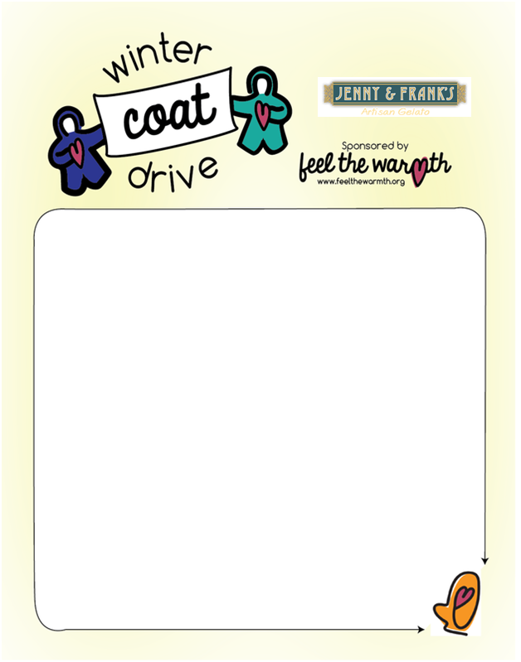
OCTOBER 17th – NOVEMBER 21st
Jenny and Frank’s is excited to partner with Feel The Warmth for their annual Children’s Coat Drive.
We will be taking donations of new and gently used children’s coats and new children’s hats, gloves and scarves.
UPDATE !! ACCEPTING ADULT SIZE COATS
PLEASE SEE “MOST WANTED” SIZES FOR CHILDREN

- Eagleview (Exton) Farmer's Market – NEW LOCATION ADDED
Thursday Nights thru Nov. 19th - Wellington Square - 3-7pm
- Phoenixville Farmer's Market
Saturdays – Oct. 17th thru Nov. 21st – 9am – 1pm
- Bryn Mawr Farmer's Market
Saturdays - Oct. 17th thru November 21st – 9am – 1pm
- Jenny and Frank's Artisan Gelato Factory Store
2847 Ridge Pk. Eagleville, PA 19403; 610.715.3343
Wed. - Sat., 2pm-9pm and Sunday 2pm-8pm til Sat. Nov. 21st
$1.00 off Jenny and Frank’s Coupon given with donation!!!

