Burnham Park Yacht Club Monthly Newsletter ● May 2016
Commodore’s Log

You may know this, but bear with me. I look at “On the Wind” as an information stream for all of the members of BPYC. Not only do I try to keep you abreast with the doings of the Club, but also in regards to other harbor events and City functions. If you look at our events/social schedule, (copies are at the Club and two (2) months are in the “On the Wind” each month) it gives concert information at First Merit (to inform you of potential traffic issues) as well as events such as the Tall Ships at Navy Pier (July 27th to July 31st) etc.
There is also information such as this: a number of your board members have met with various officials to improve security and safety for our Club and members during large concerts. We have strongly requested two (2) security people for our front and back doors. Also, the turnaround will be fenced off to prevent people standing in the streets. Reminder: No alcohol is permitted on Park District property. Our liquor license does not allow alcohol outside of our building or patio.
Tender drivers are now “required’ to ask for membership cards and numbers before pick up. Some of our wonderful “harbor friends” have taken advantage of our private water taxi.
We have eighteen (18) new members, and it’s not even June yet. A very good sign of great things to come. If you see someone at the Club you don’t recognize, introduce yourself. Sometimes it’s tough at first when one joins a new place. Make them feel like we do... at home! This makes for over two hundred members (all classes) total.
Special thanks to Dick O’Connell and Pam MacGregor for all the work on the 2016 Membership Book. It will be ready in June. Nice picture on the front cover...
The Illinois State Police have now gotten involved with their marine division along the Chicago coast with three (3) police boats. They are looking for those who are over-served or have spent the afternoon self-medicating. Please be careful!
Make a point to take the boat off the dock and go watch the first ever America’s Cup Races on fresh water. It is taking place in our City (June 10th- June 12th.) A big deal!
Two weeks later is Burnham Park Yacht Club’s most formal and traditional event, “Fleet Review” on Saturday, June 25, 2016. For those of you who are not familiar with this time honored event, it is a blessing of our fleet. The Chicago Police (Marine Unit), Fire Department, Coast Guard, DNR and many others attend with their vessels. We, as members, need to contact the Club (Samantha 312-427-4664) and get your boat registered to participate in the boat parade down the fairway of the harbor. You get a “loud” cannon salute as you pass and a complimentary bottle of Boone’s Farm Wine...just kidding! A bottle of wine at the Club with dinner that evening. Please sign up for the boat parade. It’s fun!
Take a look in the Chart Room. We have some book shelves with lots of novels etc., for your reading pleasure! Enjoy! Just return them when you’re done. Please donate any books you or your friends have read for all of us to share.
Finally, I have been working on a fun event which is set for Sunday, July 31, 2016. It is a Classic/Antique/Favorite Car Show with the cars being parked right on the sidewalk by the water in front of the Club. It is the 40th and 50th Anniversary of the two MG Clubs in the Chicagoland area. It is open to the harbor too. So, members bring down your favorite car and show it off. I am. (1953 MGTD.)
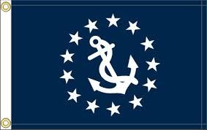
Thank you to Scott Stevenson who has offered to do this with the harbor as a promotional/marketing event for both. The Club and the Harbor. We will be offering it to 31st Street Harbor as well.
Great things are happening at BPYC. Jump in. It’s fun.

Chris Edmonds

Your Commodore

Vice Commodore

Hello BPYC Members!
"Cruising has two pleasures. One is to go out in wider waters from a sheltered place. The other is to go into a sheltered place from wider waters."
2016 is off to a Great start! I thought I would get you ready for the Season with some news in the Harbors.
A transient dock will be put by Navy Pier for Venetian night and remain throughout the Season as a touch and go dock. There will also be one at 31st street where you can stop to have a Pizza, drink, and a swim in the pool. Westrec is working on creating destinations throughout the System and a phone App to pay for the Dockage like Parkwiz works for street parking. Not everyone has a great club to visit like we do! Just call the BPYC tender and hop on for another great time. Watch the Wind and the Breeze for our scheduled events.
The Helicopter has been relocated to Waukegan allowing us much quicker response in case of emergency and the State Police will have three boats out cruising this year along with the CPD and Coast Guard.
Back to BPYC, we continue our efforts to provide internet coverage through the Harbor and Security for our Club and its Members during concert events. Ongoing dialogue is in place with all of the proper Agencies and people and we anticipate drastic improvement in both. Only time will tell, but rest assured we are doing all we can. Our Bar and Galley are fully staffed and ready for the Season. Check out the new menu then come enjoy the food, drink, and comradery.
Raise your Sails and start your Engines. The Boating Season is here!

Scott Gordon
Vice Commodore, Burnham Park Yacht Club

Rear Commodore

The plans are well under way for this years’ 78th annual Fleet review. The ceremony will take place on June 25th @ 2pm, at Burnham Yacht Club, starting with the raising of the flag, our National Anthem and the Pledge of Allegiance, followed by bag pipes and drums of the Emerald Society to perform during our memorial service. As always with Maritime traditions, a parade of boats will take place through Burnham Harbor along with the sounding of the cannon for each passing vessel. Let’s hope for great weather and an even better turn out for this annual ceremony.
Steve Theis
Rear Commodore

Secretary

Did you know.... the oldest trophy in sports is the America Cup. Chicago is hosting the event this June. It all began with a letter penned February 22, 1851. The Earl of Wilton, commodore of the Royal Yacht Squadron (RYS), in England sent a letter to John Cox Stevens, the first commodore of the New York Yacht Club with an invitation to visit
the club-house at Cowes during their stay in England. They would be very glad to help with any improvements in shipbuilding that the industry and skill of our nation may have inferior knowledge.
Commodore Stevens's respond With the warmest thanks for the invitation to visit the Yacht Club. For Stevens and his friends, the timing was incredible, a yacht, to bear the wonderful name America, was soon to be launched. America was to serve as an example of Yankee shipbuilding.
America sailed for Cowes on the Isle of Wight. Stevens issued a low-key challenge to race in a breeze of not less than six knots. The America ship owners invitation to a contest was politely ignored.
Commodore Stevens increased the stakes. He offered to race any yacht for “any sum from one to ten-thousand guineas” - this latter sum, was the equivalent of $50,000 then -- about $800,000 today.
As America waited for a race, her legend grew. America was naturally faster because of her hull shape. Pilot boats, like America , were narrow forward and showed their greatest beam amidships, which was then carried well aft. This is the knifelike shape of yachts today. Most English yachts were wide forward and narrow aft -- a shape described as “apple-bowed.”
America sailed against 14 English cutters and schooners of various sizes: from the 47-ton cutter Aurora to the 392-ton Brilliant. The usual course insued and the wind fell and the haze set in,” according to the Illustrated London News. At 6:00 pm, America neared the 223 -foot royal yacht, Victoria & Albert, Queen Victoria supposedly asked, “Who is first?" When told it was America , she asked, “Who is second?” “There is no second,” was the reply. This line became a standard for the race.
America finished the race at 8:37 that evening. Then it was an anxious night waiting for the results.
America’s victory became the stuff of legends.
The owners of America returned home without the yacht but with an ornate silver urn. The Royal Yacht Squadron £100 Cup was passed around to members of the syndicate; it was often displayed on dining-room tables. When the surviving members of the syndicate gave it to the New York Yacht Club on July 8, 1857, they called the trophy the “America’s Cup”-- named for the yacht that won it.

Your Secretary,
Bonnie Riordan
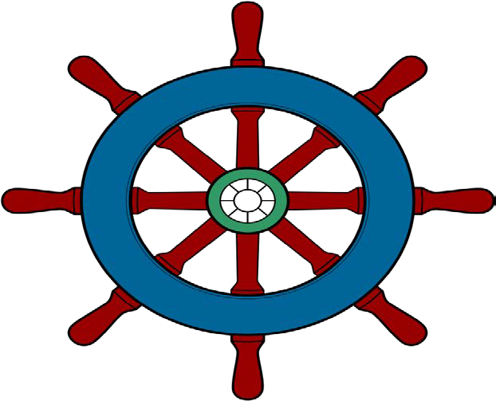

Programs

Aloha oukou
(Hello to all of you)

Sunday, May 29th Our Memorial Day celebration will kick-off with The Royale Polynesian Revue performing on the patio. The troupe is composed of fire/knife dancer, musicians and male and female dancers. Chef Sal will have a luau-themed buffet featuring a Pig Roast and Chicken kebobs.
There will be a DJ-Karaoke Show afterwards. Dance and enjoy this very special themed event at BPYC.

Monday, May 30th Memorial Day Barbecue. Chef Sal put together an amazing Buffet!

Sunday, June 19th Father’s Day Brunch. Menu will follow.

Thank you to everyone who advertised in our upcoming 2016 BPYC Directory.
Big shout out to Tom O’Connell and Dick O’Connell who worked many hours putting together a great Directory. They will be ready for distribution at our Fleet Review.

BPYC is always looking for suggestions on future live music. If you have a favorite band or type of music, we would love to hear from you. Submit ideas to pamela6341@yahoo.com

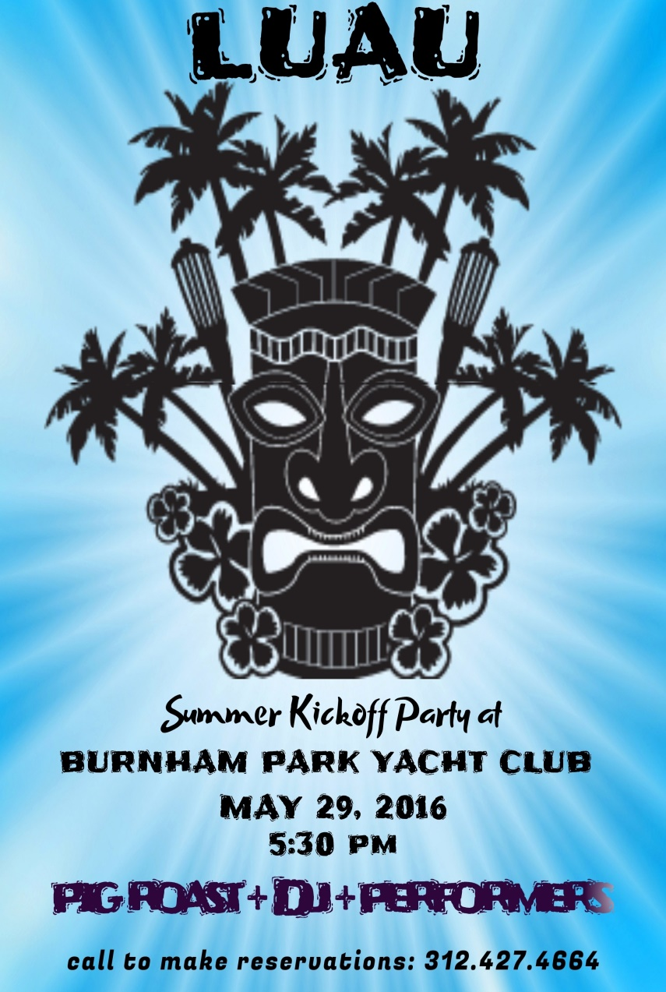

Membership
Thanks to all members who turned out to make the May 7th open house an exciting success! The bar, galley, and staff did a great job showing prospective members what a great place our yacht club is. Special thanks to Samantha as she worked tirelessly to make the event successful. We signed up many new members (double digits) that day. Let’s not let the positive momentum slow down as we will have another opportunity on Sunday June 12th to showcase the club to prospective new members. The open house will be from 12 p.m. to 3 p.m. Let’s get the word out to our fellow boaters about the great times that are happening at the BPYC! The next 10 new members will receive half off of their initiation fee. Don’t forget that existing members get a club credit for bringing in new members. Keep in mind that new membership is essential to keeping our club thriving, so bring in a new member today!
Tom O’Connell
Membership/Marketing Director

BAR Tuesday -Thursday & Sunday 12pm-10pm
Friday-Saturday 12pm-12am

DINING Tuesday-Thursday & Sunday 12pm-9pm
Friday-Saturday 12pm-10pm
Saturday & Sunday Breakfast 9am-12pm

Tender Service Tuesday-Thursday 11am-9pm
Friday 11am-12am
Saturday 8am-12am
Sunday 8am-10pm

Club Summer Hours
Through May 6, 2016

Tuesday -Thursday & Sunday
12pm-10pm
Friday-Saturday
12pm-12am

DINING
Tuesday-Thursday & Sunday
12pm-9pm
Friday-Saturday
12pm-10pm
Saturday & Sunday Breakfast
9am-12pm

Tender Service

Tuesday-Thursday
11am-9pm
Friday
11am-12am
Saturday
8am-12am
Sunday
8am-10pm

RESERVATIONS ARE REQUESTED

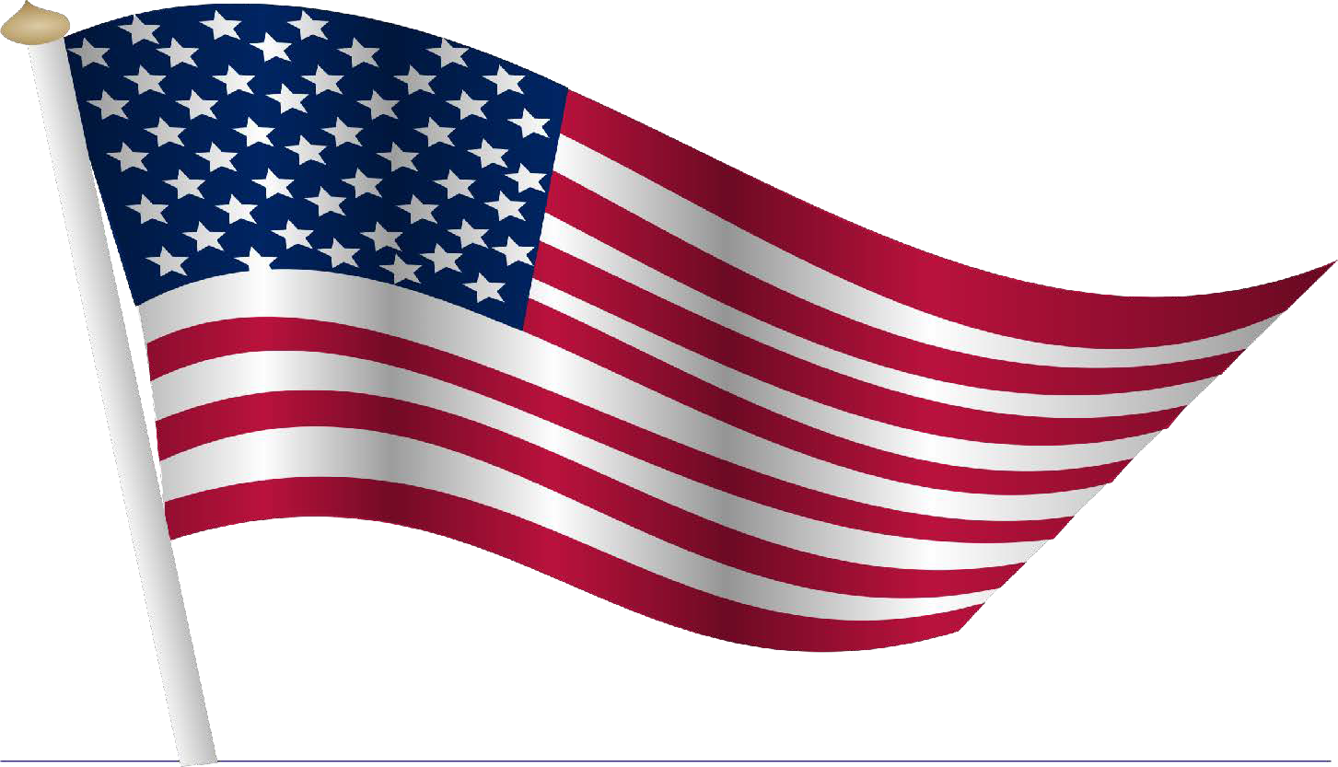

May 2016
Sun | Mon | Tue | Wed | Thu | Fri | Sat
1 | 2 | 3 | 4 | 5 | 6  Social Meeting 6:30 p.m. | 7 Full time hours ** OPENING DAY  Kentucky Derby Party  1st Open House
8  Mother’s Day Brunch (3 seating’s) | 9 | 10 | 11 | 12 | 13 | 14  WAX Educational Seminar  3:00 p.m.
15 | 16 | 17  Board Meeting 6:30 p.m. | 18 | 19 | 20 | 21  Wax Sale/Auction  1-4 WAX Educational Seminar
22 | 23 | 24 | 25 | 26  CYP Board of Directors Meeting 6:30 p.m. | 27  Annual Naval Militia Patio Party | 28  Catalina Fleet Margarita Party
29  BPYC Luau | 30  Memorial Day | 31
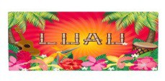

June 2016
Sun | Mon | Tue | Wed | Thu | Fri | Sat
 |  |  | 1  *The Auxiliary Meeting 6pm | 2 | 3  *Bill Patterson Reception 5pm  *Business Meeting 6:30pm | 4
5  *Sue Private Bridal Party Patio 11am | 6 | 7 | 8 | 9 | 10  *James Davis Private 200 Person Party | 11
12  *2nd Open House! | 13 | 14 | 15 | 16 | 17 | 18  *Edmonds Private Party
19  *Father’s Day Brunch | 20 | 21 | 22 | 23 | 24 | 25  *Fleet Review 4pm
26 | 27 | 28 | 29 | 30

**America’s Cup will be the 10th-12th
**Lake Shake will be the 17th-19th

Below is the bridge lift schedule for 2016

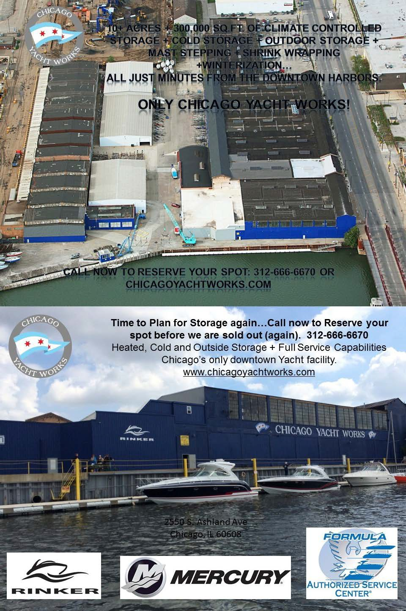
2016 Flag Officers
Commodore Chris Edmonds Vice Commodore Scott Gordon Rear Commodore Steve Theis Secretary Bonnie Riordan
Treasurer Phil Edwards

2016 Board of Directors
Two Year Directors

One Year Directors
Tom O’Connell Paulette Horne

Algis Baliunas Brij Bharteey Larry Harris Howard Jacobson Pam MacGregor Dr. Paul Stec
Bill Van Emburg

Women’s Auxiliary
President Geri Lauric

Past Commodores

Janet McCarthy Charlie Martin

1500 South Linn White Drive Chicago IL 60605 www.bpyc.com 312-427-4664

