Burnham Park Yacht Club Monthly Newsletter ● JULY 2016
Commodore’s Log

The summer is moving along way too fast, but the weather has really been cooperative for facilitating some great boating and fun events. Case in point, the recent “Pirates Ball” organized by the Auxiliary. I have not observed such great decorations and terrific menu in a long time. So many pirates and beautiful wenches. It was a great affair!

We have on our calendar the “Casino Night” set for Saturday, September 17, 2016, This is only two months away. The event requires a great deal of organization, and we need volunteers. We need you members to help with getting great donated prizes for people to bid on. They can be tickets to sporting events, weekend getaways, signed sports wear, framed art, boat rides, etc. Please call Sam at the Club and offer to help.

We also have coming in two weeks the first “Annual Car Show and BBQ” on Sunday, July 31, 2016, at 12:30 p.m. It is the two Chicagoland MG Clubs 50th and 40th anniversary. The cars are being allowed to park above the east wall right by the water’s edge for your viewing enjoyment. You can bring your favorite car too; classic, antique, favorite or modern sports car. It doesn’t matter. Then, there is a BBQ at the Club for $20.00, with a great menu.

Your Board has voted and created the Annual Nominating Committee for 2016/2017 to put together the slate of Flag Officers and Board for next year. Get involved. Let your Board and Flag Members know whom you want on the Board or offer yourself.

The food quality at BPYC has been great. Chef Sal has been creating some great specials. Ask about them when you’re at the Club.

Staff is continuing to work hard. Service is always a moving target but the Bar and Galley Committee continues to pursue perfection. It is a continuous work in progress. Patience is a virtue and is for doctors . . . get it? Never mind.

The First Merit Bank Concert Pavilion continues to be the bane of our existence. Especially with the “traffic personnel.” We are making every effort to get access to our Club for members and guests during their concerts.

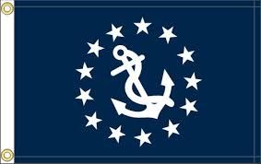
I will keep everyone informed on as many matters that concern our great Club as they arise. Until then, have a blast, and I hope to see you at the Club.

Sincerely,

Chris Edmonds
Commodore

Vice Commodore

Hello BPYC Members!
I hope you are all enjoying your vessels, the great summer weather, and the fun events at our Burnham Park Yacht Club with friends and family.

At the July Board meeting a nominating committee was selected to suggest the next incoming flag and fill vacancy on the Board of Directors. It’s now up to you if you would like to be more involved in Club operations. If you are interested in being on the Board, please contact our Commodore Chris Edmonds. He will see that your contact information gets to the Nominating Committee for consideration.

If you want to be involved, but not to this degree, please consider joining a Committee next year. They are all listed in your Directory. By the way, if you have not done so already, please pick up the 2016 version the next time you visit the Club. Sam our Manager has a copy waiting for you. This contains all the contact information for our Membership as well as our By-Laws.

We continue our efforts to provide internet coverage through the Harbor. We have found that signing in at the Harbor Masters office has been effective in helping people connect. New towers will hopefully better the Service as well. Security for our Club and its Members during concert events has vastly improved. The concert venue, park district, and the Chicago police has all stepped up. We also supplement big events with our own security service. Our Bar and Galley remain fully staffed and improve daily. They are now pooling tips and working as a Team which has resulted in better service. We hope you come often to enjoy the food, drink, and comradery.

Scott Gordon
Vice Commodore,
Burnham Park Yacht Club

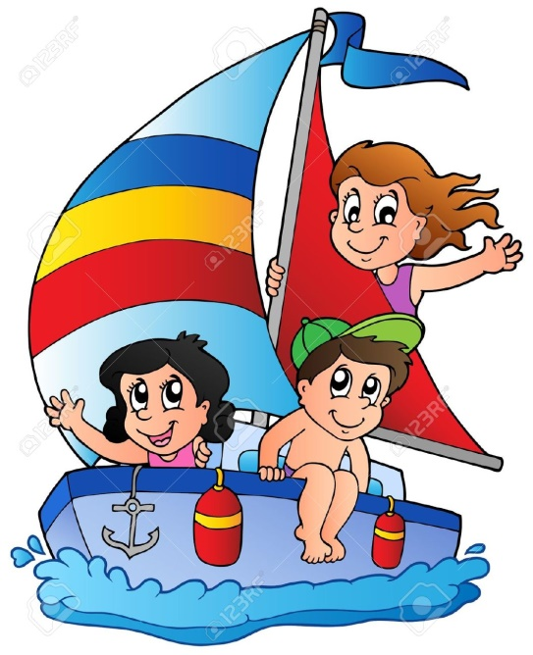

Secretary

Did you know……

In 1873 Daniel Burnham partnered with John Welborn Root to build in Chicago. After a period of struggle and hardship, the partners got a break when asked to design a home for stockyards magnate John B. Sherman. The successful completion of the project brought not only more commissions, but also Burnham’s engagement and marriage to Sherman’s daughter, Margaret. From 1873-81, after the Great Chicago Fire, both Root and Burnham took up the magnanimous task to rebuild the whole city from scratch. The firm designed more than 165 private houses and 75 public and private buildings. The two would go on to design other residential, commercial and civic structures, but their most influential works were three of their buildings that are now designated landmarks. The Rookery (1886) and the Reliance Building (1890) both used a skeleton frame construction. The sixteen-story Monadnock building (1891) was the last and tallest American masonry skyscraper.
In 1909, Burnham planned to make Chicago into a beautiful city. After the great success of the ‘White City’, he ignored all the practical aspects of planning a city and kept focusing on the visual features. Around 300 million US dollars were put into it. One great legacy was Burnham's vision of making the Lake Michigan lakefront a recreational resource. His plan proposed the creation of a string of landfill islands and peninsulas, which would provide protection against natural erosion and storms and would also be an attractive site for pleasure boating, picnics, and other outdoor activities. According to his plan there would be a lakefront and river and every resident of the city will be within a walking distance of a park. Only one island was eventually built within the city which provides for natural conservation and a beautiful sight. That Island is our very own Northerly Island and Burnham Harbor. This sweeping and well-received vision would turn out to be the pinnacle of Burnham’s life’s work. Although only one island was built, the Lincoln Park shoreline was extended with five miles of landfill. Legacies of Burnham's plan also included Lakeshore Drive and Grant Park. A ring of forest preserves surrounding the city provided the greenbelt that Burnham anticipated in 1907, long before the waves of population growth in the twentieth century transformed the city.
After completion of the Plan, he refused numerous requests to design plans for other cities and slowed the pace of his professional life considerably in the coming years, enjoying leisure and travel until the time of his death in Heidelburg, Germany in 1912.

“Make no small plans, they have no magic to stir men’s blood “
Daniel Burnham

Enjoy the rest of our boating season!
Bonnie Riordan
Your Club Secretary.

Membership

Thanks to all that helped to make the 7/10 New Membership Open House a success. Again, Sam and Sal along with help from our members delivered a successful event! We have one final Open House remaining on Friday August 19th from 5:30 to 8:30. It will be a cocktail hour and live music will be provided. Please encourage you dock mates to attend and check out all that our beautiful club has to offer. Don’t forget that we will continue to offer new members half off their initiation fees and current members sponsoring a new member get a club credit!

Plans are being made for the Casino night on September17th. We will have a silent auction. If anyone would like to donate an item for the silent auction (event tickets, memorabilia, or other interesting items) please give me a call.

Tom O’Connell
Membership Director
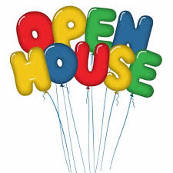

Programs

We kicked-off our 2016 boating season with an amazing Fleet Review. Dr. P. Stec and Steve Theis worked very hard to organize this successful event. CFD gave a fire stream water salute when boats passed and the day ended with a great band on the patio.

Special shout-out to The Auxiliary, Ophelia (wait staff), Ken and John (members) for their help decorating our club for “The Pirates Ball.” It was transformed into a swashbuckling event and Joann Murphy hired a very fun band.

July 31st
1st Annual Antique Car Show and BBQ @ 12:00.

The Hammond Rendezvous will be the week-end of Aug 5th – 6th. There is a sign-up sheet at the club. Paul Stec has planned a fun week-end that includes fireworks, Venetian night and dinner in Hammond harbor.

SAVE THE DATE: 2 great bands schedule to play on the patio!!!!
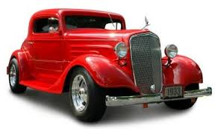
Timing is Everything August 20th
Cool Rockin Daddies August 27th

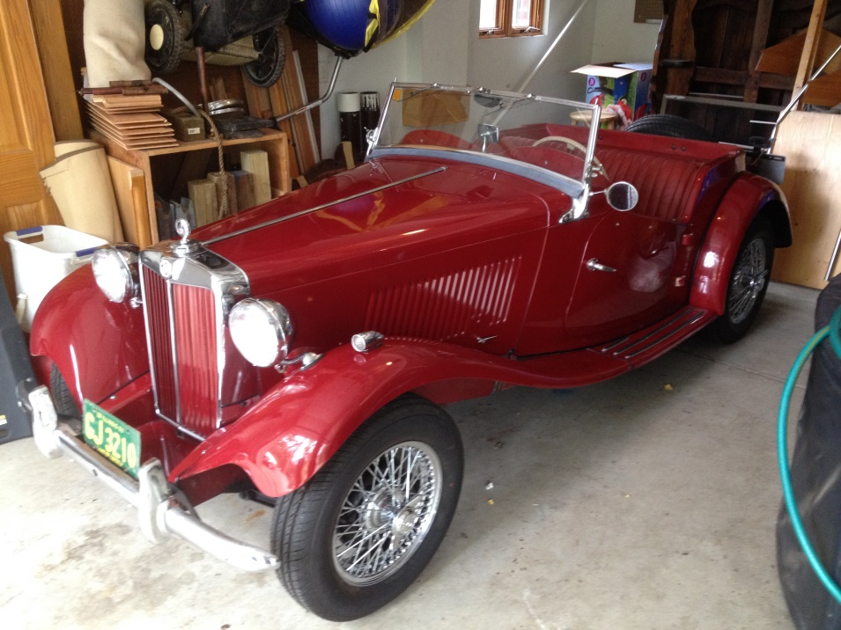

The Auxiliary
The Pirate’s Ball was absolutely fantastic. The decorations thanks to Pat Baliunas, Carol Shirmang, and Joann Murphy were outstanding.The band did a great job of keeping us entertained as did quite a few of the costumes worn by some of our members.

We are thinking of having a painting party on August 27th on the patio. More information will follow. Anyone that was here last year really enjoyed wecoming new artists.

The next meeting is August 5th at 6:30pm. Please make a point to attend.

Geri Lauric, President
The BPYC Auxiliary

HELLOOOO MATEY. Join us on July 9th for our Pirate’s Ball. Food will be served aboard the USS BPYC and will consist of a Pirates buffet, served from 6:30Pm to 9:00PM. The music by Tropical Experience will be from 5:30PM to 11PM. Please make sure you call for reservations so we can make sure you will be seated. The number to call is 312-427-4664, and ask for Sam.

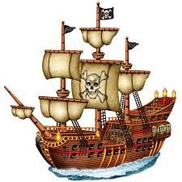
Thank you to everyone who participated in the Auxiliary’s Boating Auction, it was a great success. Most of the items for sale were donated to the Auxiliary, which we really appreciated. Whatever was not sold will be donated to the Sea Scouts.
The next Auxiliary meeting is July 8th at 6:30PM, which has been moved a week so not to interfere with everyone’s 4th of July holiday.
See you at the club.

Geri Lauric, President
The BPYC Auxiliary

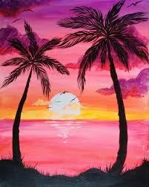
Patio Painting
Party!!!
July 2016
Sun | Mon | Tue | Wed | Thu | Fri | Sat
 |  |  |  |  | 1  Social Meeting 6:30pm  Possible BBQ | 2  Possible Music and BBQ
3 | 4  4th of JULY | 5 | 6 | 7 | 8  The Auxiliary Meeting 6pm  Private Party Patio 7pm | 9  Pirates Ball!!! 5pm
10  3rd Open House | 11 | 12  Board Meeting 6:30pm | 13 | 14 | 15 | 16
17 | 18 | 19 | 20 | 21  Private Party Dining Room | 22  Private Party Chart Room 5:30pm | 23  Private Party Patio
24 | 25 | 26 | 27  Tall Ships At Navy Pier---------------------- | 28  ------------------------------------------- | 29  ------------------------------- | 30  ------------------------------

31
Antique Car Show BBQ!! 12pm

August 2016
Sun | Mon | Tue | Wed | Thu | Fri | Sat
 | 1 | 2 | 3 | 4 | 5  The Auxiliary Meeting at 6pm  Social Meeting at 6:30pm  Hammond Rendezvous Weekend | 6  Private Patio Party at 1pm
7 | 8 | 9 | 10  Private Book Club at 6pm | 11 | 12 | 13  Poker Run & Dingy Raft Off
14 | 15 | 16  Board Meeting at 6:30pm | 17 | 18 | 19  Last Open House!! | 20  Air and Water Show
21  Air and Water Show | 22 | 23  Private Party at 6pm | 24 | 25 | 26  Private Party | 27  The Auxiliary Paint Party!  Private Party
28 | 29 | 30 | 31

BAR Tuesday -Thursday & Sunday 12pm-10pm
Friday-Saturday 12pm-12am

DINING Tuesday-Thursday & Sunday 12pm-9pm
Friday-Saturday 12pm-10pm
Saturday & Sunday Breakfast 9am-12pm

Tender Service Tuesday-Thursday 11am-9pm
Friday 11am-12am
Saturday 8am-12am
Sunday 8am-10pm

Club Summer Hours
Through May 6, 2016

Tuesday -Thursday & Sunday
12pm-10pm
Friday-Saturday
12pm-12am

DINING
Tuesday-Thursday & Sunday
12pm-9pm
Friday-Saturday
12pm-10pm
Saturday & Sunday Breakfast
9am-12pm

Tender Service

Tuesday-Thursday
11am-9pm
Friday
11am-12am
Saturday
8am-12am
Sunday
8am-10pm

RESERVATIONS ARE REQUESTED

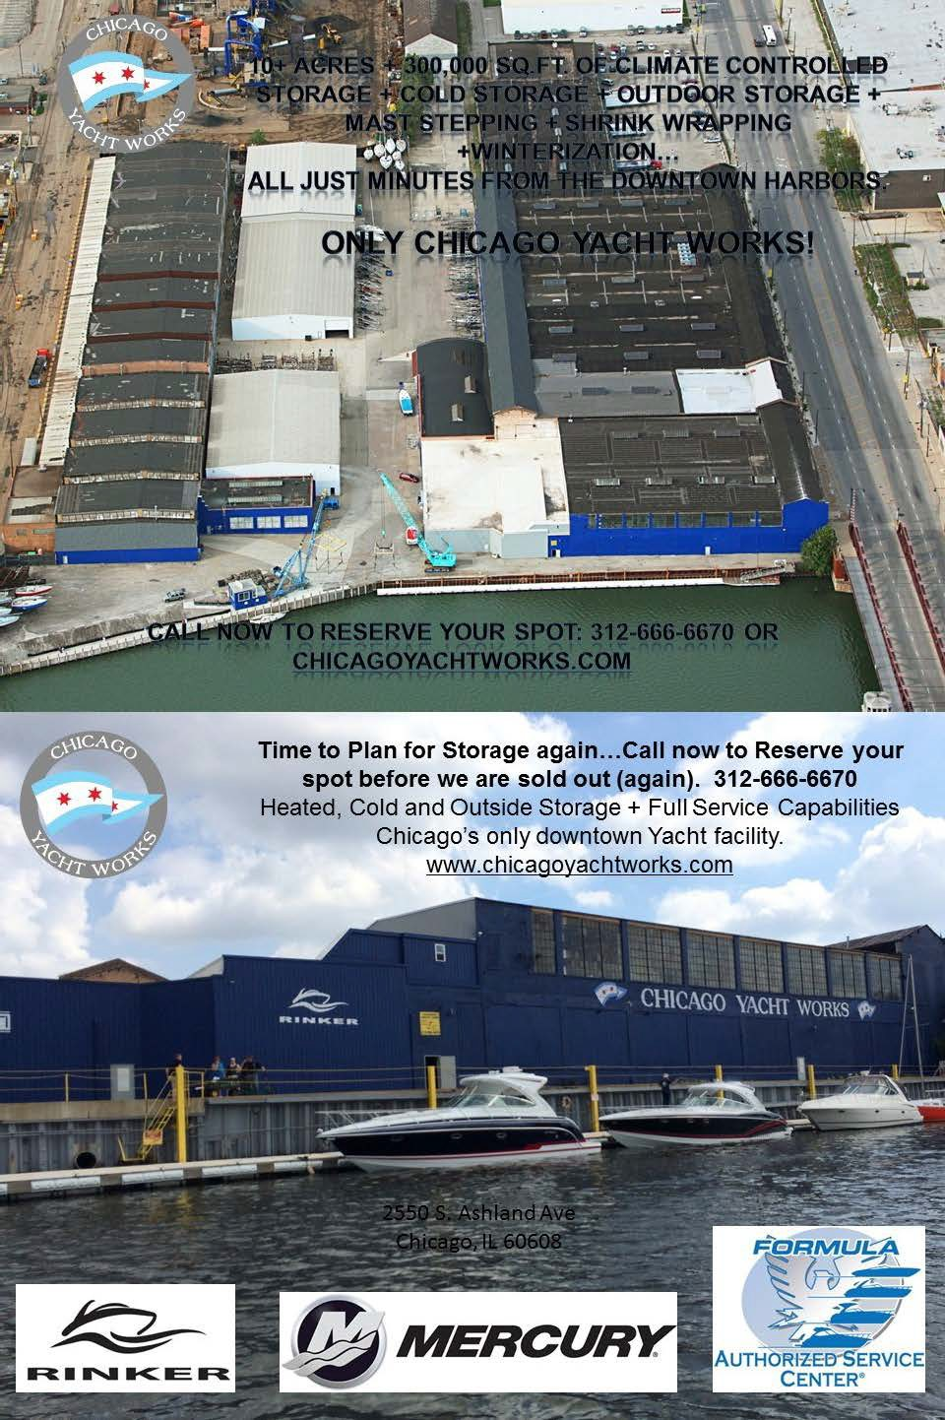
2016 Flag Officers
Commodore Chris Edmonds Vice Commodore Scott Gordon Rear Commodore Steve Theis Secretary Bonnie Riordan
Treasurer Phil Edwards

2016 Board of Directors
Two Year Directors

One Year Directors
Tom O’Connell Paulette Horne

Algis Baliunas Brij Bharteey Larry Harris Howard Jacobson Pam MacGregor Dr. Paul Stec
Bill Van Emburg

Women’s Auxiliary
President Geri Lauric

Past Commodores

Janet McCarthy Charlie Martin

1500 South Linn White Drive Chicago IL 60605 www.bpyc.com 312-427-4664

