

Take advantage of our promotion on TRAVELZOO
and enjoy, brunch, lunch or dinner at a discounted price!!!
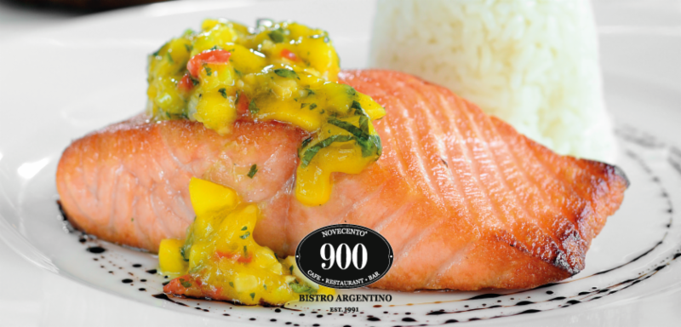
AVENTURA
Travelzoo deal
18831 N Biscayne Blvd, Aventura, Fl, 33180
Ph: (305) 466.0900
RESERVATIONS

BRICKELL
Travelzoo deal
1414 Brickell Ave, Miami, Fl, 33131
Ph: (305) 403.0900
RESERVATIONS

KEY BISCAYNE
Travelzoo deal
620 Crandon Blvd, Key Biscayne, Fl, 33149
Ph: (305) 362.0900

MIDTOWN
Travelzoo deal
3201 Buena Vista Blvd, Miami, Fl, 33127
Ph: (305) 576.7447
RESERVATIONS
ww

