Industry:
Healthcare/Education
Category:
Drainage

Location:
Spokane, WA
Installation:
Orion acid waste system

“We’ve been using Orion acid waste piping since the mid-1990s. It’s been a mainstay for our hospital and laboratory work since we first used it."

- Gary Solberg, McClintock & Turk, Inc. Project Supervisor and Manager

WSU Spokane Riverpoint Campus Biomed Lab
Lab goes all-in for green
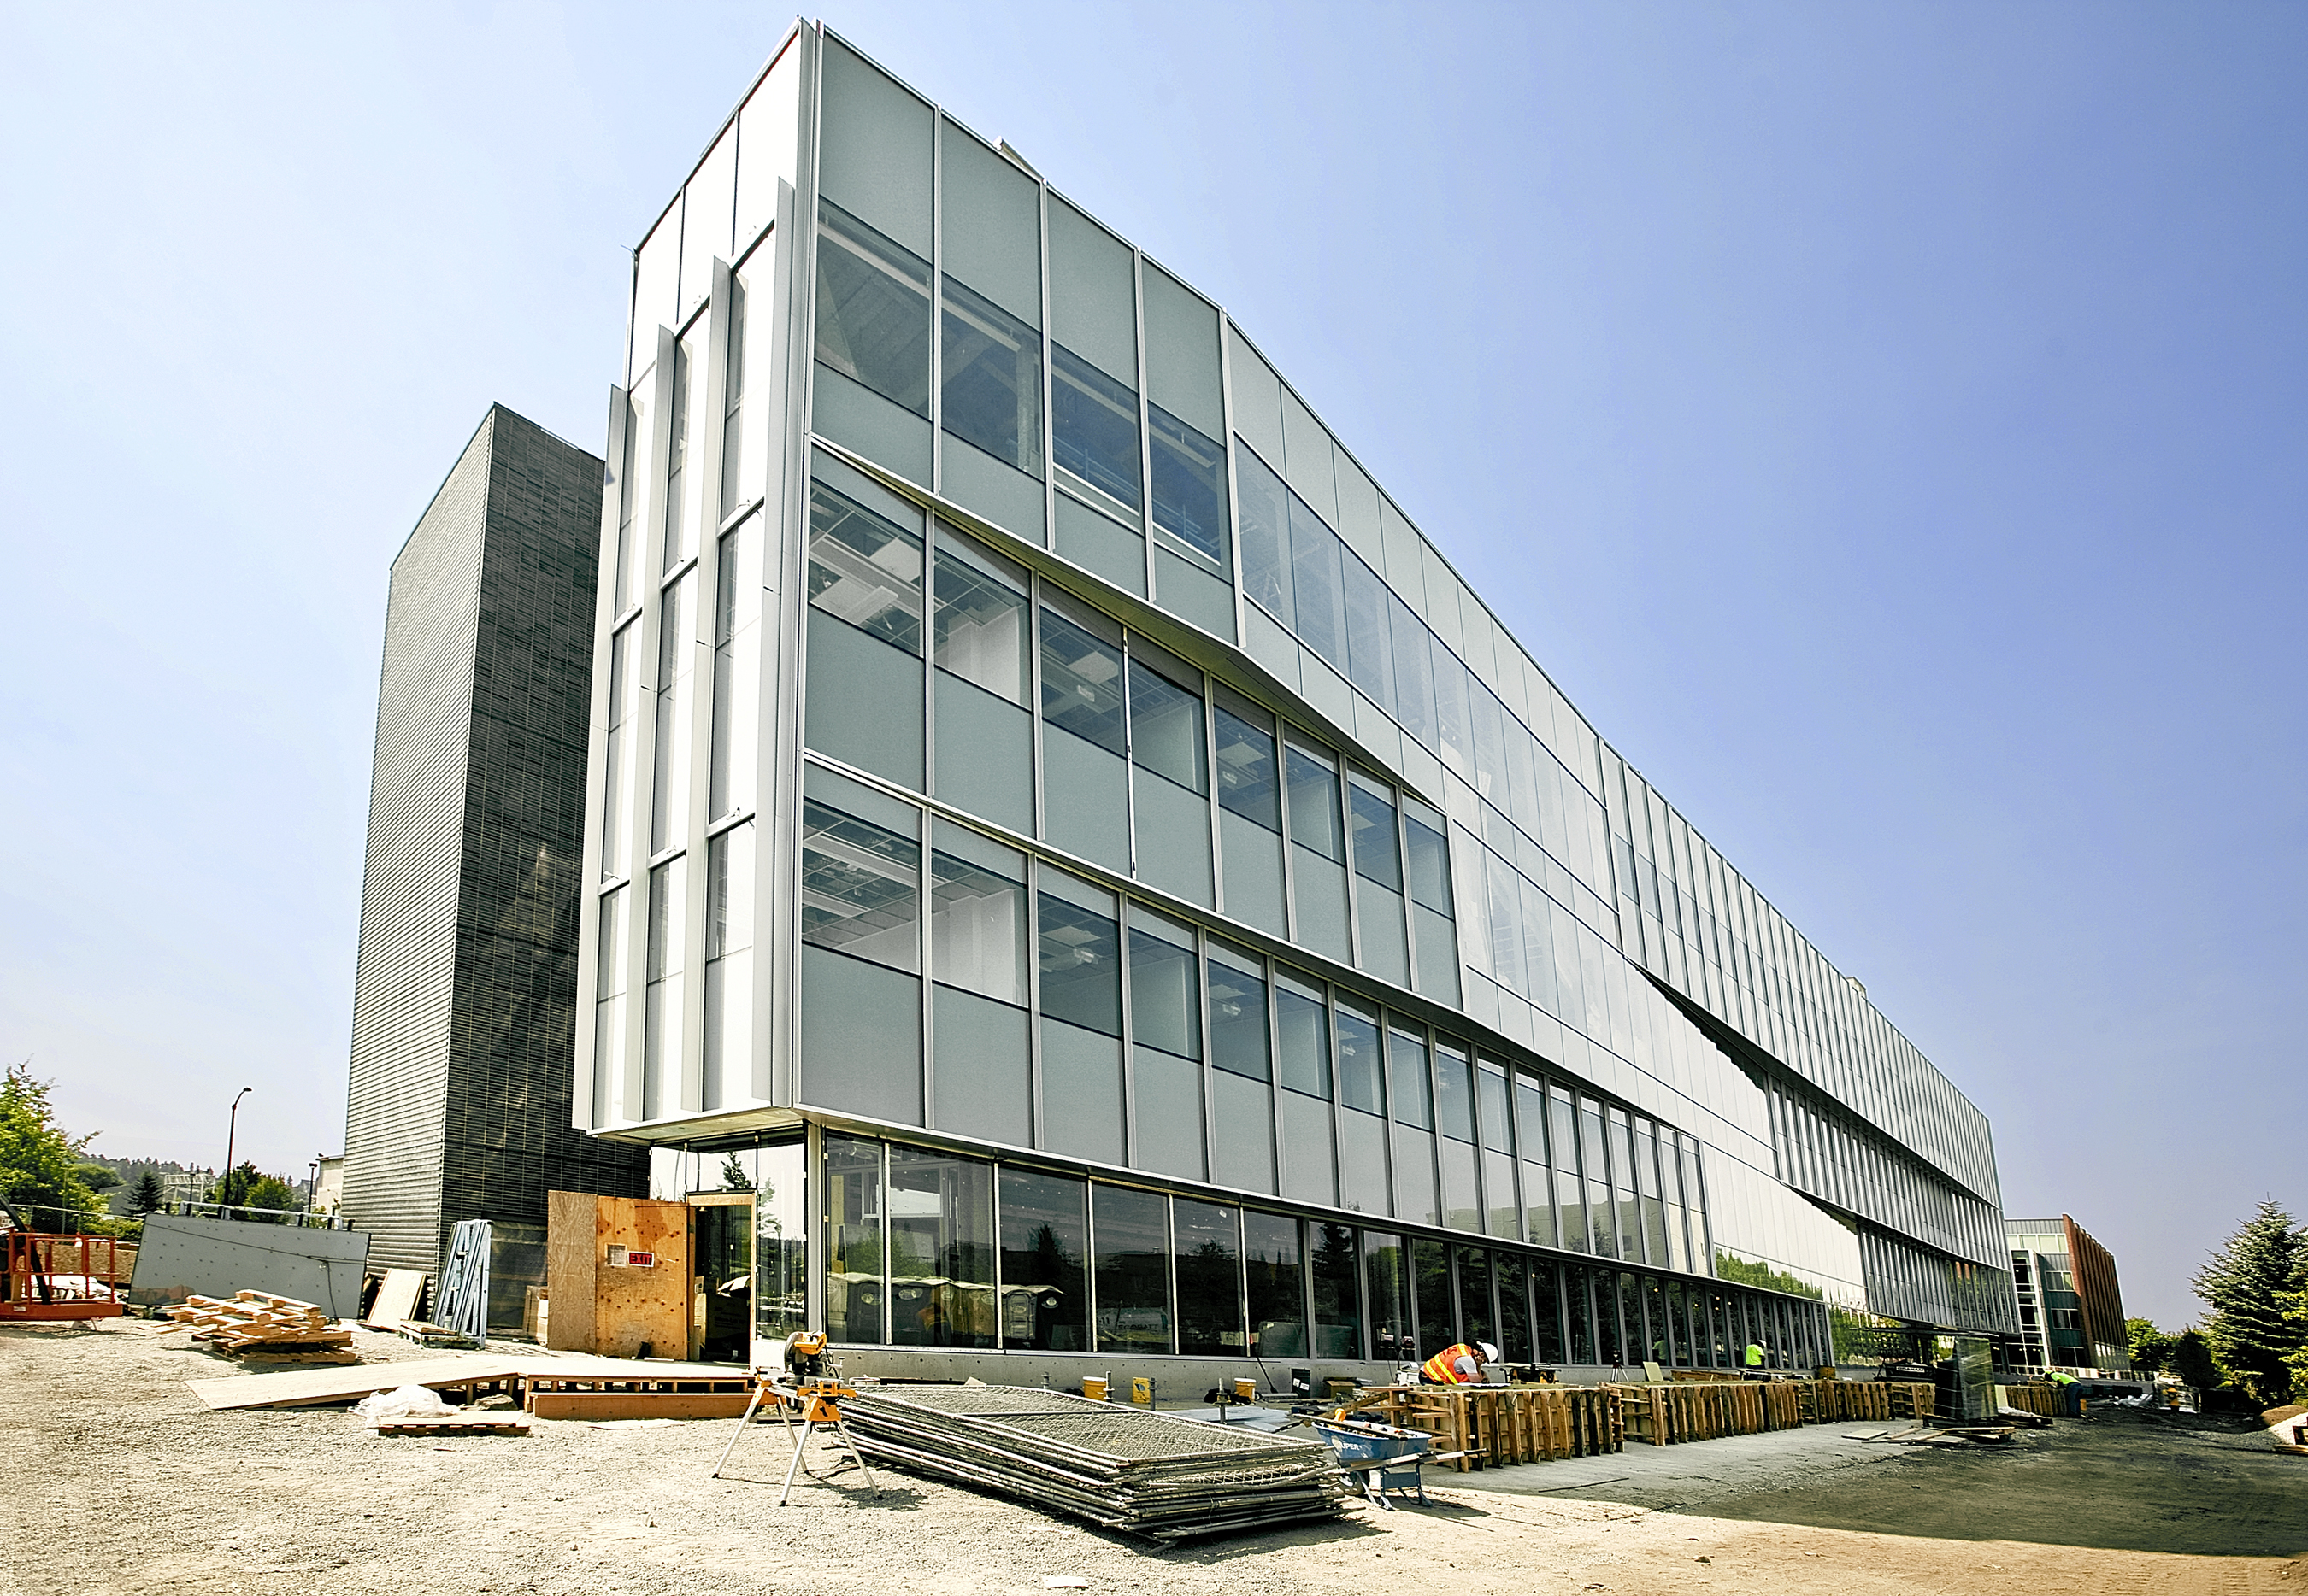

CUSTOMER: WSU Spokane Riverpoint campus

SCOPE: Build a new biomedical facility to achieve LEED Silver rating, with an acid waste pipe system to handle hazardous chemicals.

CHALLENGE: The facility handles caustic and potentially hazardous material; it needed the best acid waste disposal system possible.

SOLUTION: Orion waste system installed.

RESULTS: The Orion chemical waste system is compatible with a wide range of temperatures and chemicals, as well as being plenum-rated for flame spread and smoke generation – all assets to help the new biomed building achieve the highest effectiveness and energy efficiency possible.

When Washington State University (WSU) administrators made plans for a new biomed facility, the goal to achieve energy efficiency went under the microscope.

Because it is a facility that handles caustic or potentially hazardous chemicals and materials, the Biomedical Health Sciences building required an acid waste disposal system. Gary Solberg, project supervisor and manager at McClintock and Turk, Inc., knew that Orion acid waste piping would be their best option, because it is made of material that is compatible with a wide range of temperatures and chemicals and is plenum-rated for flame spread and smoke generation.

