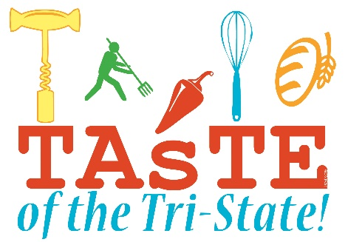
Become a SPONSOR of the “Taste of Tri-State”
Sunday, March 20th, 2016
The Tri-State Chamber’s “Taste of Tri-State” Festival offers you four great ways to promote your business to more than 60,000 people. We rely on our sponsors to help us keep our costs low, thereby keeping booth costs affordable each year for our local businesses.

GOLD SPONSORS | $1000.00 | Beneﬁts include:
Internet Advertising • Newspaper & Radio Advertising
Radio Interviews • Listing in Newspaper inserts
(20,000 print run) • Press Release
Name on Promotional banners
DAY OF FESTIVAL: FREE 8’ booth ($200 value)
Listing in Festival Directory
Sponsor boards & booth sign

SILVER SPONSORS | $500.00 | Beneﬁts Include:
Internet Advertising • Newspaper & Radio Advertising
Listing in Newspaper inserts (20,000 print run)
Press Release
DAY OF FESTIVAL: Discount on 8’ booth ($100 value)
Listing in Festival Directory
Sponsor boards & booth sign

NOTE: Payment and form must be received on or before February 18th, 2016 to included in ALL advertising!
BRONZE SPONSORS | $250.00 | Beneﬁts Include:
Internet Advertising • Newspaper & Radio Advertising
DAY OF FESTIVAL: Listing in Festival Directory
Sponsor boards & booth sign

FESTIVAL SUPPORTERS | $25.00 - $200.00
Receive Listing in Festival Directory

For more information, please call Susan Dickinson at (860) 393-9171 or email: sdickinson@tristatechamber.com

Please return the bottom portion with payment.
------------------------------------------------------------------------------------------------------------------------------------------

I would like to be a *Gold * Silver *Bronze * Supporter (circle one) Payment enclosed $______________________
Company (for signage) ________________________________________________________________________________________
Address (for marketing) _____________________________________City: ____________________________Zip: ______________
Contact Name: __________________________________________Email: _______________________________________________
Phone: ____________________________Website: __________________________________________________________________
____I need electricity ____This is my first time participating

Payment must accompany this completed registration form to be included in advertising and to reserve a booth.
Please make checks payable to: Tri-State Chamber of Commerce Mail to: PO Box 386, Lakeville, CT 06039

Or to pay by credit card: Amex Mastercard Visa (circle one)

Total $_________________Card #_____________________________________ Exp. Date: ______________Sec. Code: __________

Name on Card: _______________________________________________________________________________________________
Billing Address: _________________________________________City: ____________________________Zip: ________________
Signature: ___________________________________________________________________________________________________
A $5.00 fee will be charged to all credit card payments.

