Kenilworth Garden Club

Cookbook (2nd edition) Order Form

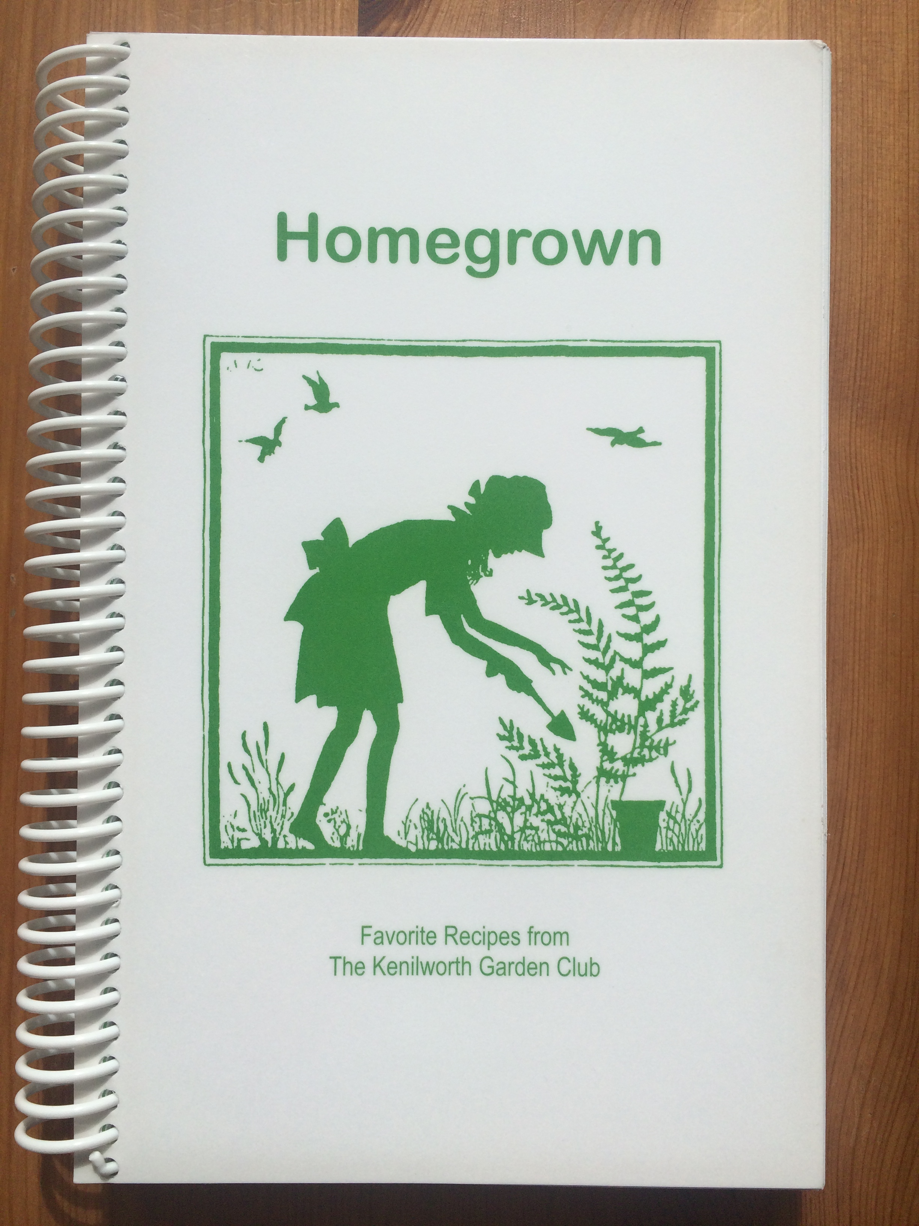

Name: ____________________________________________

Phone Number: ____________________________________

_______ Cookbooks @ $15.00 each (sold at cost) $ ___________

Donation to KGC Philanthropy/Outreach $ ___________
(suggested donation is $5-$10 per cookbook)

TOTAL ENCLOSED: $ ___________

Please send this form and your check (written out to Kenilworth Garden Club with
Cookbook in the memo line) by March 17, 2016 to confirm your order to:

Stephanie Keehn
607 Laurel Ave.
Wilmette, Illinois 60091

Thank you!

