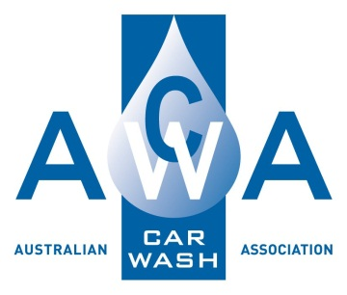
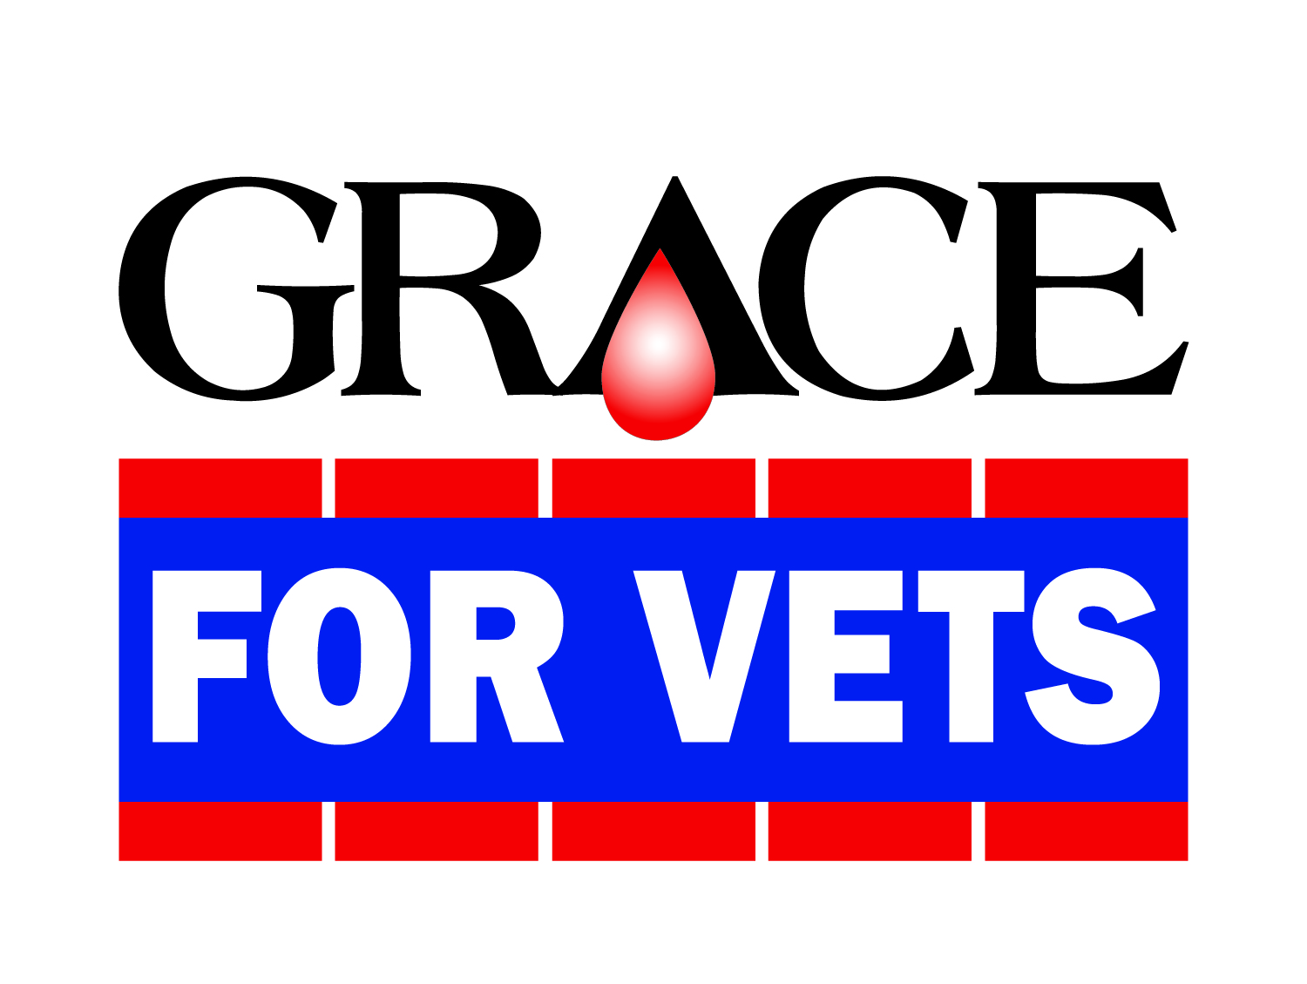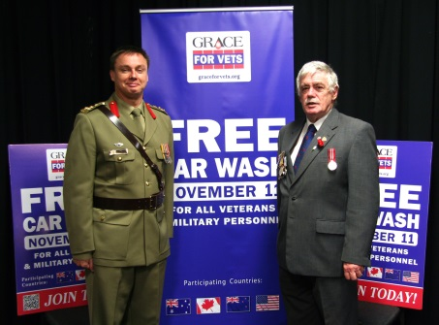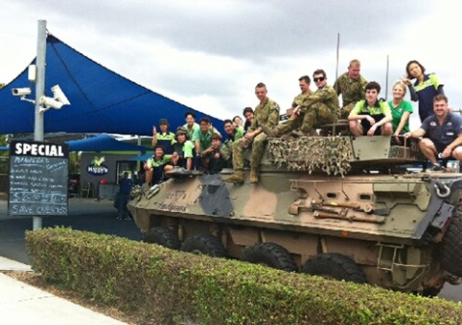

Annual Free Car Wash for Veterans and Service Personnel
GRACE FOR VETS on Remembrance Day 2015

This is the fifth year in which Australian car wash operators will be providing free car washes to veterans and currently serving military personnel, as their way of saying thank you to those who have given so much to uphold the values and security of Australia.
Grace for Vets was founded in 2004 by Mike Mountz, an ex-serviceman profoundly moved by visits to Veterans hospitals in the USA. Started at his own car wash in Philadelphia, last year more than 2,000 car washes joined in, in the USA, Canada, Australia and New Zealand.
The Australian Car Wash Association (ACWA) manages and promotes the Grace for Vets program in Australia. We have enjoyed working with the RSL Clubs, as the peak national veterans support organisation, to help us ensure that all your members and their families know where and how they can be honoured by the car wash industry in November.
We have information posters for you to display at the RSL Clubs and we would hope that you will also advise your members in newsletters and emails about this special free service which will be available to them. Participating car washes could also sell poppies for you between now and November 11th
Veterans, war widows and current personnel just arrive on the day and say that they are, or have been, part of the military. No proof is required; it is an honour based program. Note that there may be limits on the hours when an attendant is on duty to provide the service – your local car washes will give you that information.
As new car washes register all the time, service personnel would be advised to find participating washes for Australia at www.graceforvets.org. or by calling 1300 00 2292.
Thank you for helping us to recognise and honour your members.
Yours sincerely,

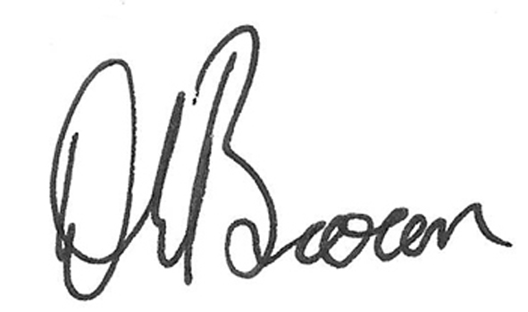

Darren Brown
National President
Australian Car Wash Association

