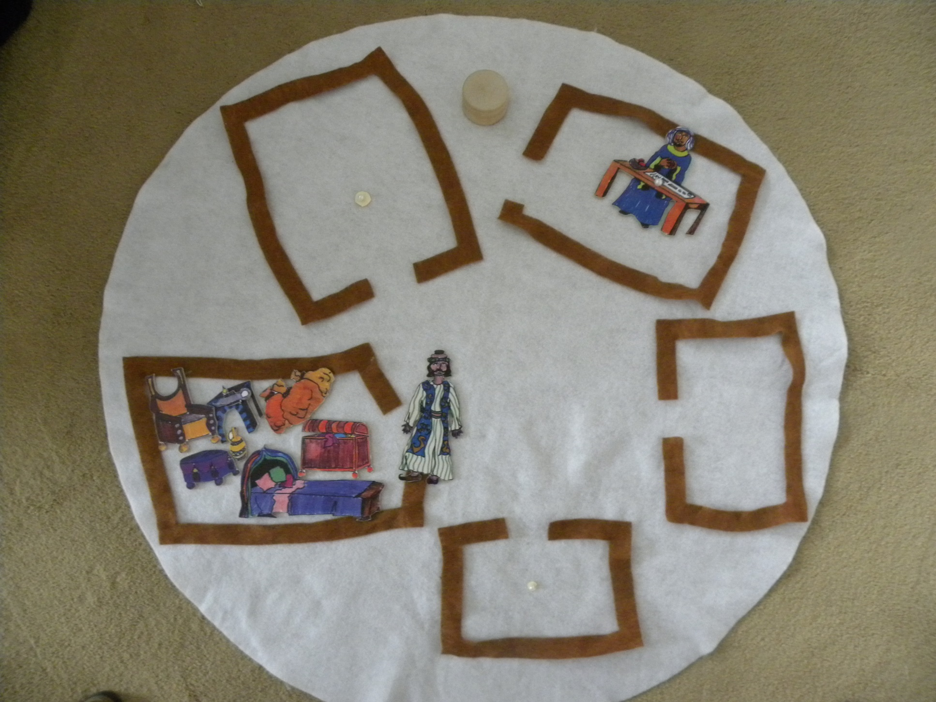

**The Seller**

**The Merchant**