

**HOW TO PARTICIPATE**

**MATH CHALLENGE 2015-2016**

[](http://www.bing.com/images/search?q=stack+of+papers+clip+art&view=detail&id=792309B7B290AA263F2BCEB66152BA9F7675E991)[](http://www.bing.com/images/search?q=thumbs+up&view=detail&id=E3F8E1BC2B26F3AC727A14D9A3001B7C08CFB8BA&qpvt=thumbs+up)[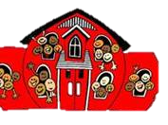](http://www.bing.com/images/search?q=teacher&view=detail&id=90FA6B89832BDEE00DA221E7F0F08D773649DF7D&first=456)[](http://www.bing.com/images/search?q=family+clip+art&view=detail&id=B7369234E3254177DCF29AF6A7F170CA48739D9D&first=116)[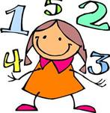](http://www.bing.com/images/search?q=math&view=detail&id=8D90B96F486F5BAA0745C98D8E20B5ABF9383302&first=38)