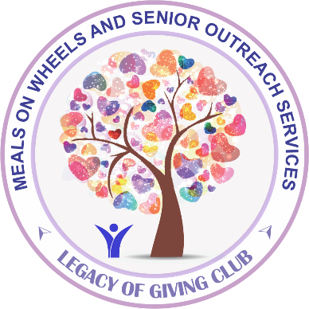

**Planned Giving**

**Become a member of the Legacy of Giving Club**

Pledge to include Meals on Wheels and Senior Outreach Services in your estate planning.

Legacy gifts allow you to support the organization in a much larger manner than you might otherwise be able. Gifts do not cost you anything now and can provide an easy way to assure a lasting impact on your community.

There are many ways to give to MOWSOS. Through planned giving you can:

• Generate income now and into the future

• Reduce taxes

• Preserve wealth for your family

For more information, please contact Elaine Clark at [elcark@mowsos.org](mailto:elcark@mowsos.org) or 925-937-8311.

**Board   
of Directors**

**John Judd** Chairperson

**Cathie Ramie**Vice Chairperson

**Lauren Smykowski**Secretary

**Christine Scimia**Treasurer

**Gabrielle Comfoltey**

**Dr. Eric Freitag**

**Emily Hopkins**

**Dr. David Levien**

**Linda J. Weihofen**

*Meals on Wheels   
and Senior Outreach Services is a nonprofit 501(c) (3) organization (IRS #68-0044205).*