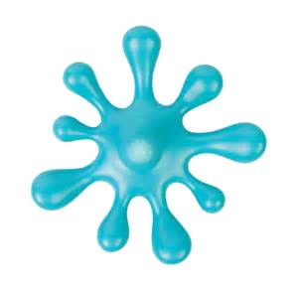
Let's Make Oobleck!
Friday, April 17 @ 10:30 am

At HOWLAND PUBLIC LIBRARY
Art , Science & Hands-On Fun!
For children 3 – 5 years-old with an adult

But what is Oobleck? Art and science intersect in this fun program for the preschool set. Measure and mix simple ingredients. Discover how this non-Newtonian fluid can behave like a liquid and a solid. Engage the right and left sides of your brain in this STEAM*-powered morning!
*STEAM = Science, Technology, Engineering, Art & design, and Mathematics

Instructor, Kate Daley, educator and mom from Beacon, will help children to experiment like a scientist and create like an artist!

To register, please contact Ginny Figlia, at 831-1134 x.103; youth@howlandlibrary.org

