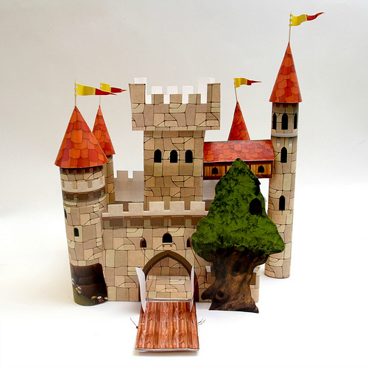
July 6th at 4:30 PM
Catapult your Way into a Real World of Fantasy
Open to Middle / High School Aged Teens / Registration Required
Design & Build your own Paper castle, Labyrinth & other Medieval Games!

TEEN SUMMER READING @ Mamaroneck Library
136 Prospect Avenue Mamaroneck NY 10543
(914) 630-5875 www.mamaronecklibrary.org
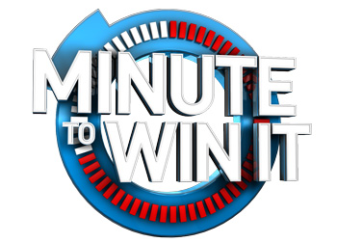
July 13th at 4:30 PM
Minute to Win It Competition!
Test your skills & Win Prizes!

Open to Middle / High School Aged Teens / Registration Required
10 challenges using household items,
60 seconds on the clock, Think you can win it?
Compete Against yourself, Compete against Your Friends
TEEN SUMMER READING @ Mamaroneck Library
136 Prospect Avenue Mamaroneck NY 10543
(914) 630-5875 www.mamaronecklibrary.org

July 20th at 4:30 PM
Project Runway Team Challenge
Open to Middle / High School Aged Teens / Registration Required
Collaborate & create couture
Fashion Show competition
TEEN SUMMER READING @ Mamaroneck Library
136 Prospect Avenue Mamaroneck NY 10543
(914) 630-5875 www.mamaronecklibrary.org

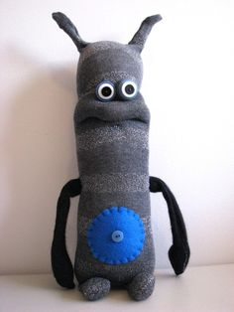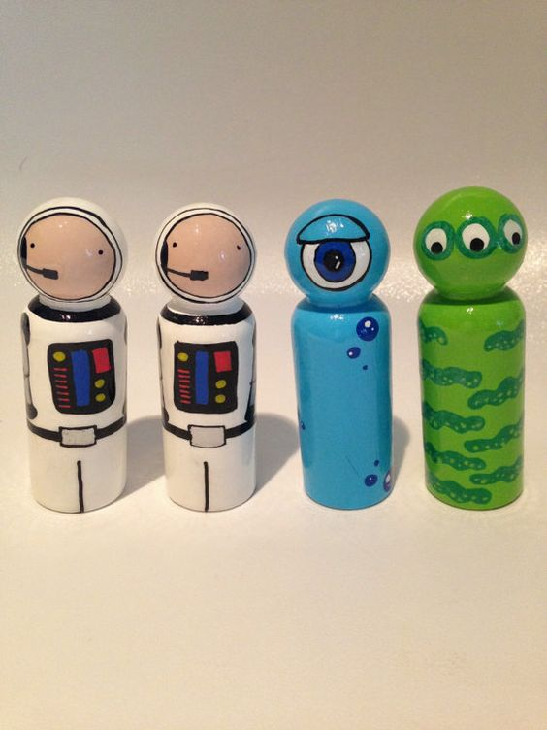
August 1st at 4:30 PM
Creepy Peg dolls & Ugly Pets
Open to Middle / High School Aged Teens / Registration Required
Simple stuffing, stitching & Painting creatures of your own design
TEEN SUMMER READING @ Mamaroneck Library
136 Prospect Avenue Mamaroneck NY 10543
(914) 630-5875 www.mamaronecklibrary.org
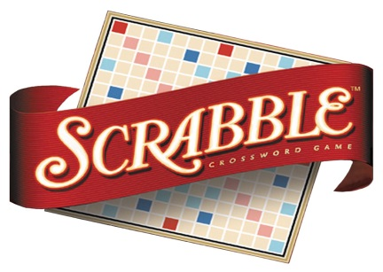
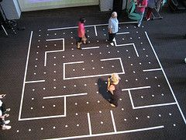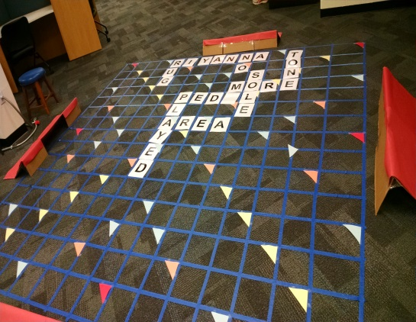
August 10th at 4:30 PM
LIVE Action Pacman & Floor Scrabble
Open to Middle / High School Aged Teens / Registration Required
TEEN SUMMER READING @ Mamaroneck Library
136 Prospect Avenue Mamaroneck NY 10543
(914) 630-5875 www.mamaronecklibrary.org

