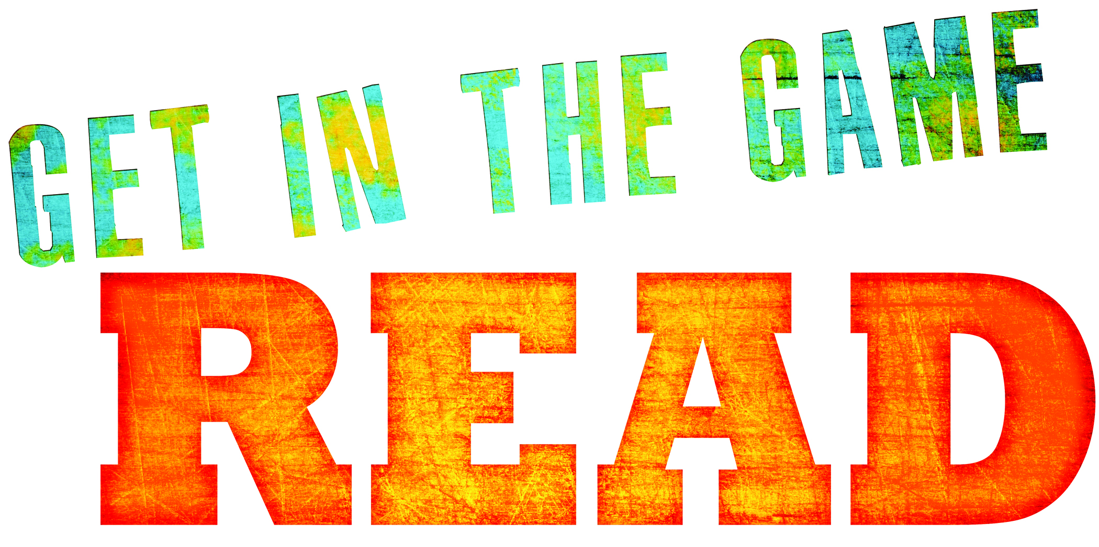




5th Annual Teen Art Exhibit*
Monday, August 8th - 31st
Public Reception & Awards Presentation:
Saturday, August 13th from 2:00-3:00 PM
Deadline for Application & Submission: Friday, August 5th at 4PM.
1 piece per artist/ any medium
Open Middle &High School Aged Teens

* Registration required /space & materials limited

If you are interested please contact Ellen in the
Mamaroneck Teen Library: 136 Prospect Ave / 914-630-5875/www.mamaronecklibrary.org

