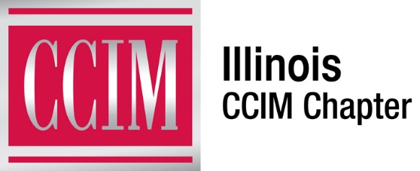
WILLINGNESS TO SERVE

The Illinois CCIM Chapter is always looking for people to serve as committee members and/or on the Board of Directors. If you would like to become more involved in the Illinois CCIM Chapter, now is your chance. Simply indicate your interests below and someone will be in contact with you shortly.

Thank you.

DIRECTOR
Directors are elected for a two-year term. As a member of the Board of Directors, you will be representing Chapter members in Illinois.

COMMITTEE VOLUNTEER
Please check the committees that interest you.

_____ Sponsorship
- Identify and solicit sponsors for the Chapter and Special Events.

_____ Membership
- Build and maintain chapter membership, and develop and implement strategies for recruiting and retaining Chapter members.

_____ Networking
- Provide programs and events that encourage and promote networking and relationship building for the Chapter

_____ Education and Candidate Guidance
- Promotes and provides education opportunities throughout the year for CI and other educational programs

_____ Candidate Guidance / Designation Promotion
- Assist and Guide CCIM candidates through the candidacy process. Promotes the CCIM brand.

_____ Budget / Audit
- Assist and Guide CCIM candidates through the candidacy process. Promotes the CCIM brand.

_____ Programs
- Responsible for preparing the budget and monitoring the financials of the Chapter

_____ Nominating
- Solicit candidates for board elections
Create a proposed slate for directors and executive committee

_____ Legislative Affairs
- Monitors and reports on critical legislative issues to the Chapter.

_____ J. Keepper Society
- Consists of past chapter presidents to promote student memberships and provides mentoring and scholarships.

_____ Marketing / Communications
- Develops and executives an annual plan to improve communications to members, public and media.

Name:

Company:

Address:

City, State, Zip:

Fax:

Telephone:

Email:

Date:

Please return to:
Illinois CCIM Chapter
214 N. Hale Street, Wheaton, IL 60187
Telephone: 630-510-45528 Fax: 630-510-4501
jsvazas@integrated-solutions.com

