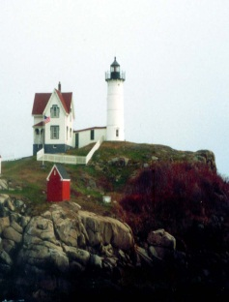

SAVE THE DATE!!!!

Fall 2016 CRNNE Conference

When: Wednesday October 5th, 2016
Where: College of the Holy Cross
1 College St.
Worcester, MA 01610

