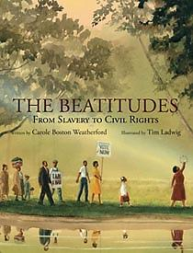
The Beatitudes, From Slavery to Civil Rights
by Carole Weather ford, illustrated by Tim Ladwig
Call no 323 We 2010
“Starting with "Blessed are the poor in spirit: for theirs is the kingdom of heaven," the Beatitudes form the beginning of Jesus' Sermon on the Mount. This new children's book uses those blessings to motivate a powerful poem describing how African Americans found hope and inspiration during pivotal points in time from slavery to the Civil Rights movement. Striking watercolor and pastel paintings further add to the richness of this book.” Review from Amazon.com

