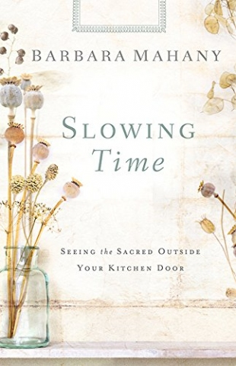
Slowing Time, Seeing the Sacred Outside Your Kitchen Door
by Barbara Mahany
Call no.242 Mah 2014
"In our hyper-e-networked world, too many of us live under the tyranny of the urgent. With Slowing Time, Barbara Mahany reminds us how not to lose sight of the things which are truly important--the beauty, serenity, and sanity that we can find in life's calm and quiet moments. Whether the chirping of a bird, the tingle of an autumn breeze, or the hug of a child, Mahany helps us to see that when we entertain the seemingly mundane dimensions of life, we are embracing the sacred!"
"We need whatever we can get to help us pay closer attention, be more awake to the moment, more alive amidst the clamoring distractions of the internet age. Barbara Mahany gives us a treasure--a thorough, practical guide full of wisdom, blessings, recipes, luminous facts, and elegant language. With her as our astute and patient leader, we gain an intimate knowledge of the seasons." Reviews from back cover.

