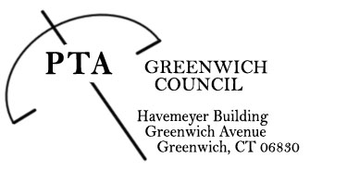

The PTA Council Essence Award Committee and PTA Council Executive Board

Invite you to the

Essence Award Recognition Ceremony
To honor our 2016 Nominees and Recipient

2016 Essence Award Nominees

Leslie Breck, Parkway, CMS, GHS
Laura Erickson, Riverside, EMS, GHS
Diana Gonzalez, WMS
Jane Hentemann, North Street, CMS
Amy Leahy, Old Greenwich
Amy Phillips, Riverside
Diane Roina, Hamilton Ave
Lisa Sylvester, Glenville
Kathleen Yu, Riverside, EMS, ALP

Wednesday, June 8, 2016
Board of Education Building
290 Greenwich Avenue, Greenwich
10:00 a.m.

Please RSVP by May 28
Marty Dayton and Neile Messer, PTAC Essence Committee
PTACessence@gmail.com

