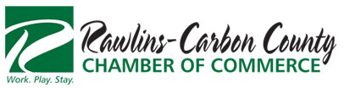
PO Box 1331
Rawlins, WY 82301
307 324-4111
Tax ID: 83-0141240

The Rawlins~Carbon County Chamber of Commerce would greatly appreciate your sponsorship for this year’s Cow Plop Festi-Bull in the parking lot of the Tractor Supply store, Saturday, August 1, 2015.
Deadline for Sponsorship is June 29th, to be included in promotional advertisement and material.

Name: ___________________________________________________________

Address: ___________________________________________________________

City, State, Zip Code: ___________________________________________________________
Sponsorship Donations:
The Head Bull $1,000
- Prominent logos in any advertisement including print, radio, and flyers
- Band promotion during event
- Banner (if applicable) displayed at event
- Recognition during Cow Plop
- 1st 4 top Sponsors receive a commemorative gift
Full of it $500
- Logos in any advertisement including print and flyers
- Band promotion during event
- Banner (if applicable) displayed at event
Little Heifer $250
- Advertisement in print
- Flyer advertisement
- Banner (if applicable) displayed at event
Sponsorship can be mailed to:
Rawlins Carbon County Chamber of Commerce
PO Box 1331
Rawlins, WY 82301
Your support is greatly appreciated!
Sincerely, Committee Chair: Missey Turney
Elizabeth Hunt
Executive Director

