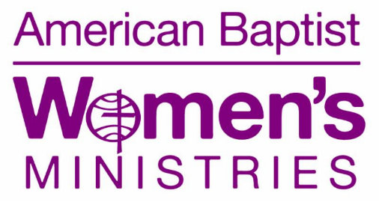
Interfaith Dialogue for Peace in Myanmar and around the World

You are invited on Saturday, May 2, 1:00 p.m., at Lake Avenue Baptist Church, to hear Al-Haj U Aye Lwin of Myanmar (Burma) speak about conflict transformation and peace-building in conflict-torn Myanmar, as well as the critical role interfaith dialogue plays in peace-building globally.
Being a Myanmar National selected and gold-medalist volleyball player, Al-Haj U Aye Lwin is in physical education by profession. He is now serving as a member of the board of management at the Diplomatic School in Yangon, Myanmar.

Additionally, Al -Haj U Aye Lwin is Chief Convenor at the Islamic Center of Myanmar and a founding member of Religions for Peace Myanmar (www.religionsforpeaceinternational.org). His interest in Sufism began at an early age and he is now Spiritual Guide Kalifa of Qadariya Aarliya Sufi Order, Myanmar.

He has lectured on Islam and comparative religions since 1974, and has authored, translated, and edited more than a dozen books; he has presented papers, seminars, and workshops in Myanmar and internationally. We are excited to welcome him to Rochester!

Rev. Sandra L. DeMott Hasenauer
Associate Executive Director
American Baptist Women’s Ministries
P.O. Box 851
Valley Forge, PA 19482-0851
www.abwministries.org

Subscribe to our blog: www.intheirshoesblog.wordpress.com
Listen to our podcast: www.intheirshoespodcast.org

