American Baptist Women’s Ministries
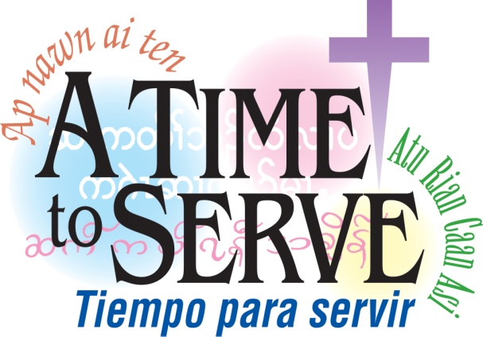
Rochester-Genesee Region

SPRING MEETING AND
EVENING OF FELLOWSHIP

Thursday, May 7, 6:30 pm – 8:30 pm
Ogden Baptist Church
721 Washington St, Spencerport, NY

Guest Speaker: Rev. Dr. Vera Miller,
Pastor of Genesee Baptist Church
All women are welcome!

Reminder: Please support our 2015 local mission project by bringing personal hygiene items, socks, undies, etc., for Cameron Community Ministries and our Love Gift Offering will go to support outreach programs at Cameron Community Ministries

Questions: Phone Helen Hoffman at 585-314-9136

