Want to know how many challenges you have completed?
This is NOT where you check challenges completed in this fiscal year
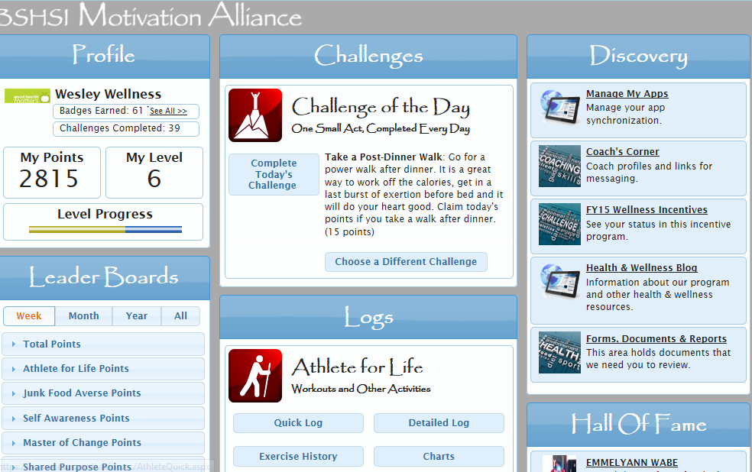
Click on FY15 Wellness Incentives to see how many challenges you have completed in this fiscal year

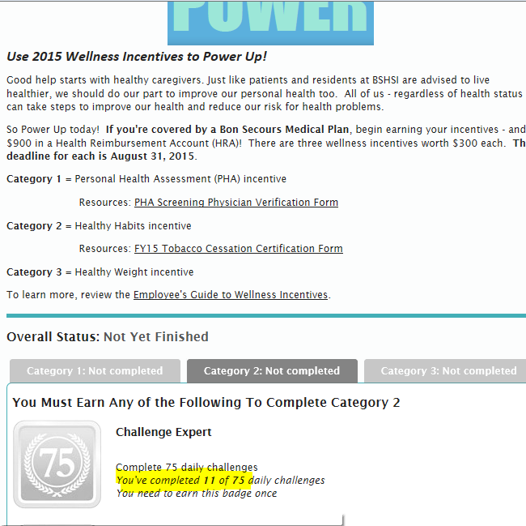
Category 2 shows you how many challenges have been completed since September 1, 2014 (this fiscal year). You must complete 75 by August 31, 2015

