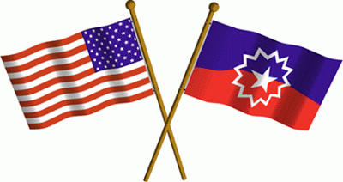
The Race Coalition of Fredericksburg invites you to be part of the 150th Juneteenth Anniversary celebration 2015.
Juneteenth is the celebration of the last of the slaves being freed in Galveston Texas, when General Gordon Granger presented general order#3, freeing all the slaves. This was 2 ½ years after the signing of the Emancipation Proclamation and 2 months after the civil war ended.
Juneteenth 2015 will be a fun-filled time to enjoy friends, family and an opportunity to make new friends. This event will serve a greater purpose as it gives the community an opportunity to experience cultural rejuvenation, pride and unity. It will give the community the chance to teach, learn and inspire all nationalities, ages and gender on the importance of history, culture and Freedom. Having your support is crucial to the success of Juneteenth 2015 and our commitment to the community. We are asking for the following donations:
Water Sound System Cards Forks
Soda Trash bags Tickets Paper Plates
Potato Salad Crafts/games for children Jump ropes Napkins
Baked Beans Certificate paper Grill/charcoal Cups
B Q Chicken Ink cartridges Card tables Catsup
Hot dogs Juneteenth bands Paint (face painting) Mustard
Buns Juneteenth flag Beads (bracelets) Relish
Cookies American flag Card tables/chairs Aluminum foil
Chips Horseshoes Amp/Mics Cooks
We greatly appreciate any and all donations, we are asking donations be in by June 10, 2015. For questions please contact: Eunice Haigler@ 540-429-6322 or blessedhaigler@aol.com.
Monetary donations to: Deborah Caprio, 9631 Edenton Rd, Parlow, Virginia 22534

