Dear Friends:
Please join me for “Come and See,” our Annual Fall Clergy Retreat. We will begin with registration at 3 p.m. on Monday, October 19, and continue through lunch on Wednesday, October 21, at Shrine Mont in Orkney Springs, Virginia.

Our retreat will be led by Patricia A. Parachini, SNJM, D.Min. Pat, who is known to many in this Diocese, is a pastoral theologian, educator and spiritual director. In a ministry spanning more than 40 years, she has written extensively on preaching, liturgy, and spirituality, led retreats in national and international settings, and is currently affiliate faculty at Loyola University, Maryland, and The Catholic University of America.

Pat writes “Jesus invited his disciples to ‘Come and See.’ During our retreat, you will be invited to do just that; “to spend time with Jesus, learning about him and his way through the perspective of the gospel of Luke.” Pat will guide us “to more deeply appropriate gospel spirituality and develop a personal plan for following the Way of Jesus.” Our retreat together will include ample time for quiet reflection. I hope you will find this time engaging, renewing for your sense of vocation and invigorating for your ministries.

The deadline for registration is Friday, October 16. This conference is an appropriate use of discretionary funds and scholarship assistance is available. Fees and registration procedures are explained on the form. To increase scholarship availability, I invite those who can to contribute to scholarships for others by sending your gift to the Diocese of Virginia in care of my office, with a note on the check, “Fall Clergy Retreat scholarship gift.” If you have questions, contact Kendall Martin via e-mail at kmartin@thediocese.net or at 800-DIOCESE ext.1029.

Our fall retreat is an important time of renewing the bonds of our common ministry, as well as strengthening ourselves vocationally. I know you will want to make every effort to be present for the entire retreat.

Faithfully yours,
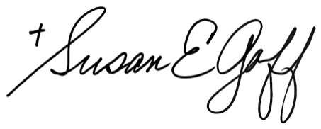

The Rt. Rev. Susan E. Goff

