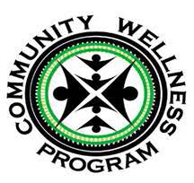
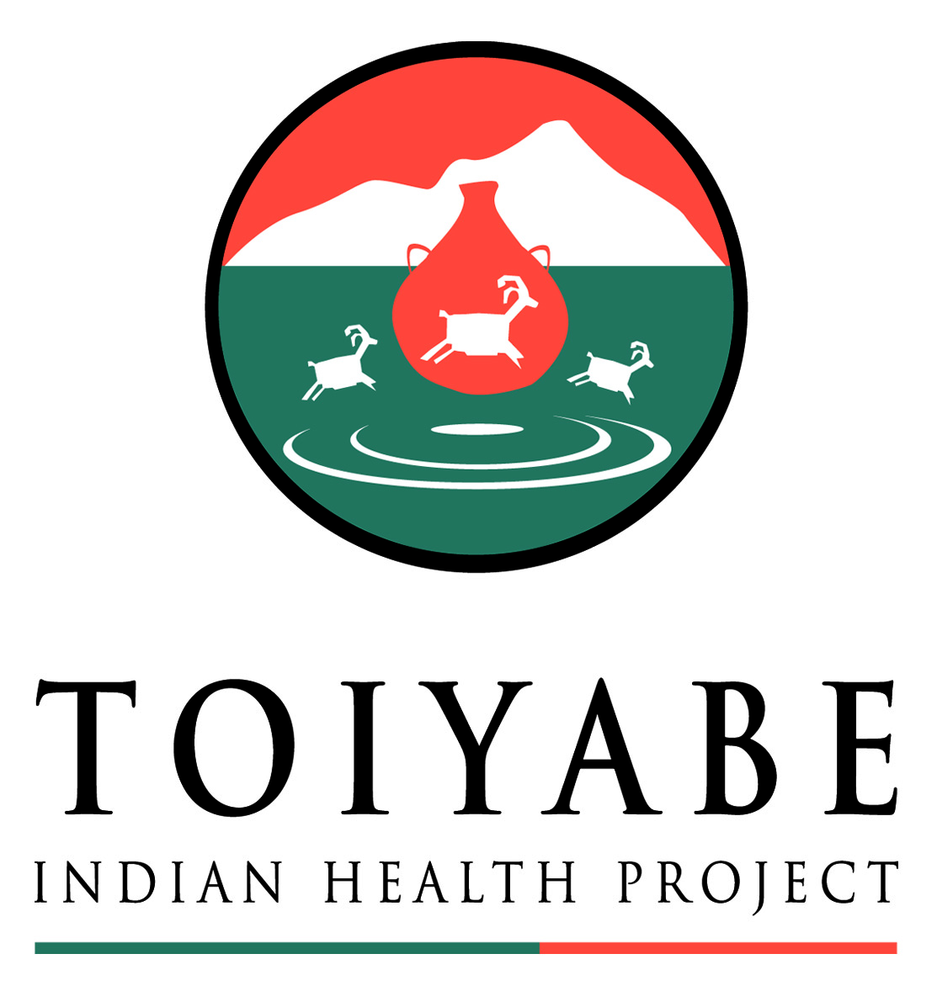
Toiyabe Community Wellness Program
Request for Funding

Person requesting funds: Date:
Project title: Tribe/organization:
Email address: Phone number:
Check addressee: Check mailing address:
Total amount requested:
1. Please provide a brief explanation of the work/purchases you will use this funding for.

2. How will your work/purchases support Community Wellness Program objectives (healthy eating, active living, and/or commercial-tobacco free lifestyles) in Tribal communities?

3. What is the anticipated number of people reached through your work? ______________

4. Please attached a budget that includes an itemized breakdown of costs adding up to the total amount requested.

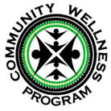
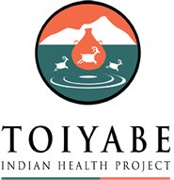
Toiyabe Community Wellness Program
Terms and Conditions

1. Funding is made possible with grant money awarded by the Centers for Disease Control and Prevention (CDC). CDC prohibits these funds from supporting lobbying and/or work that requires a building permit.

2. Only Tribes/organizations with the administrative capacity to carry out sound fiscal recordkeeping are eligible to receive funding. An individual person requesting funding must partner with a Tribe/organization that will serve as a pass-through body to manage funds and oversee accounting.

3. Toiyabe Indian Health Project is not responsible or liable for any harm or injury resulting from funded work. By accepting funding, the Tribe/organization agrees to accept all liability associated with the funded work.

4. Submitting a funding request is not a guarantee that funding will be provided.

5. Please allow up to 2 weeks (10 business days) for Community Wellness staff to respond to your funding request. If approved, allow an additional 2 weeks (10 business days) for a funding check to arrive.

6. Funds may only be used for the work/purchases listed in the proposal. Any budget modifications or changes to project spending require prior written approval from the Community Wellness Program.

7. The Community Wellness Program reserves the right to publish media pieces about our partnership with funded Trines/organizations (including, but not limited to: photos, newsletter articles, Facebook posts, etc.)

8. The Community Wellness Program requests funding source acknowledgement on any media/communications pieces that the funded applicant shares with the public. Please include the Toiyabe Indian Health Project and Community Wellness Program logos in any media, and inform Community Wellness staff at least 24 hours before any media is published.

I agree to the terms & conditions above and am authorized to sign for the hosting fiscal Tribe/organization.

Signature ____________________________________ Date: ______________

Please email completed application to Kate Morley (kate.morley@toiyabe.us) OR
drop off completed application at the Preventive Medicine Department, 52 Tu Su Lane, Bishop, CA 93514
For Internal Use Only:
Approved Denied Project Coordinator __________________________________ Date___________
Approved Denied Program Manager ___________________________________ Date___________
PICH (53-6) REACH (54-6) PICH and REACH (53-6/54-6) API Number:
Notes:

