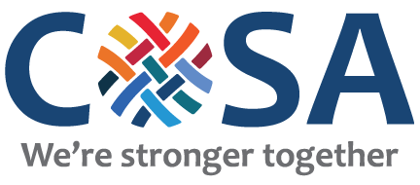

COSA MEETING DATES
2016-2017

September 16 Annual Breakfast

September 29 (Thursday)

October 25 (Tuesday)

November 17 (Thursday) – Please note this is the 3rd Thursday

December 13 (Tuesday) - Please note this is the 3rd

January 26 (Thursday)

February 21 (Tuesday)

March 30 (Thursday)

April 25 (Tuesday)

May 23 (Tuesday) 3rd Annual Provider Fair

(Alternates 4th Tuesday or Thursday)

All meetings take place at
Berkshire Children & Families
220 Russell Rd. Hadley
From 9:00 am – 10:30 am

