
NEWBORN – 6 MONTHS MESSAGES
THE IMPORTANCE of TALKING, READING, SINGING, and PLAYING

General Message: Right from birth, babies are listening, looking, and learning. So find – and enjoy – those everyday moments when you can talk, read, sing, and play together with your baby.

Use the physical exam as a teachable moment: Model for parents how to talk and sing with a newborn. Point out how the baby responds (e.g. “Look how interested she is. She’s really paying attention!”) Show parents how easy this is and describe the many benefits of responding to their infant!

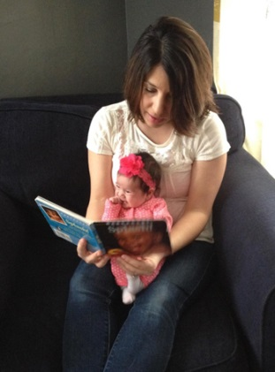
NEWBORN – 3 MONTHS
- A newborn's world is full of loud and unexpected noises. Your voice is the most
familiar and comforting one.
- Talk and sing quietly to her as you nurse. This is a special time for full attention.
- Babies talk to you by cooing, babbling, kicking their feet, crying, touching, smiling. Respond to these cues! When you do respond, so will your baby. These first conversations make babies feel loved and help them learn language.
- Talk as you cook or do household chores; sing as you rock her to sleep or go to
daycare; wiggle her toes and kiss her belly while changing or dressing her; name things as you walk.
- If it feels right, read to your baby, or just talk about the pictures. As you read, hold her on your lap or up against your chest. She’ll enjoy the closeness and the sound of your voice.
- Remember that babies won’t focus on a story the way an older child would. That will change as she grows.
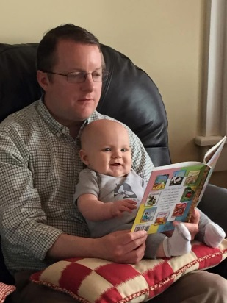
4 – 6 MONTHS
- Babies want to learn! So, notice what your baby pays attention to and continue
talking back and forth, singing and playing. Point at and name things. Together
you are building a strong bond and a strong brain.
- Babies learn from caring adults. They don't learn from hand-held devices or TV
because screens can’t respond to babies the way people can!
- You can now more easily look at books together with your baby because he’s less
wobbly, but he still needs support. Notice when he smiles, babbles, and focuses on
your face as you talk or read!
- Reading together is one more way for him to hear more – and different – words. It won't be long before he says "ma,” “ba,” and "da." Board books are best for this age, especially because he will want to chew on them. (And that’s OK!) Let him reach out to touch or bat the pages!
- If you have other children, create a family circle by holding the baby while you read to them.
Older brothers and sisters can read to the baby too, making them all feel connected and caring!
- Remember, when you talk, sing, read, and play together you are helping his brain make connections that will help him learn to talk and to read when he gets older! Have fun!

