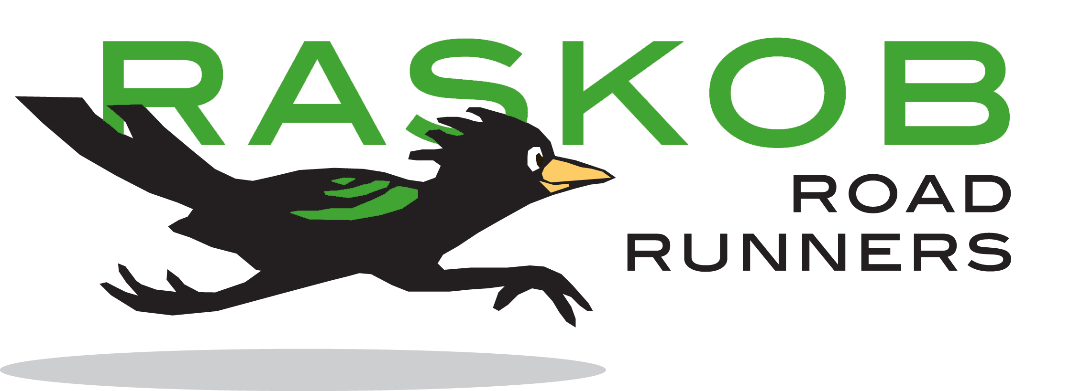
Annual Parent / Guardian Contribution Request: $55 Suggested Level
Our goal is 100% parent / guardian participation in contributing RPA dues this year! The suggested donation is $55, but please contribute at a level that is comfortable for you. Please make checks payable to Raskob Parent Association or RPA. Dues may also be paid using a credit card and the form is attached. Your contribution is tax - deductible to the extent allowed by law. Tax ID # 94-1358307 (Raskob Day School)

Raskob Parent Association Membership and Benefits:
All parents or guardians of students enrolled at Raskob Day School are automatically members of the RPA’s general membership. Benefits include:
- Investment in teaching tools and resources to enhance learning at Raskob; fundraising to support investment
- Parent education and other gatherings for Raskob parents
- Coordination of room parents and volunteer opportunities
- Book fair with LD appropriate books; Spirit Wear sales
- Weekly RPA Notes with important reminders and pertinent information
- Hospitality offered at a variety of gatherings including Open House, Winter Concert and Annual Awards Night

Purpose:
The purpose of the RPA is to promote our children’s education by supporting the parents, students, and staff at Raskob Day School. We achieve this by fostering volunteerism among parents; fundraising and securing resources; community building; facilitating communication; providing staff appreciation; and furnishing parent education and support.

Examples of RPA Purchases during 2014 and 2015:
RPA parent contributions play an important role in supporting our students and community. In 2014 and 2015, membership contributions, in addition to other RPA fundraising efforts, supported the purchase of picnic tables for the yard, Chromebooks and storage cart, Kindles, document cameras and projectors, playground equipment and refreshments for events such as Open House and teachers’ appreciation week.

RPA budgets, requests and distributions are approved by vote of the RPA members during regularly scheduled meetings.

Please clip and mail

Annual Raskob Parent Association Contribution

Name ___________________________Child’s Name & Grade_________________________

Please mark your choice: One time $55______ Other $________

Checks are payable to Raskob Parent Association or RPA
Send to: Raskob Day School, Attn: RPA Contribution, 3520 Mountain Blvd. Oakland, CA 94619
Thank you for your support!

