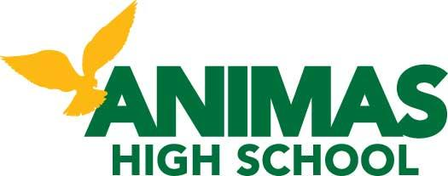

Dear Osprey Families,

In our ongoing commitment to communication and transparency, the Head of School Search Committee would like to outline the search process and to inform all of our Osprey families of our next and final steps.

The Board made a motion back in December to conduct an official Head of School search, as they had promised would happen from the time that Jake Lauer stepped into the Head of School position in 2013. Jake had been appointed to the HOS position without going through the Bonanza process that all employees at AHS must go through before hired, and it became clear that it was in the best interest of the organization for the Board to make good on its promise. Jake agreed with this decision, and asked the Board to move forward with the HOS search process.

We created a Search Committee with the idea that we wanted to represent all key stakeholder groups. It was important to make sure that this committee was well balanced; the committee consists of individuals that represent our founders, parents, teachers, staff, students and board members.

We posted our job description for the HOS position January 27th. After closing the posting by the first week in March, we had a total of 15 applicants. After reviewing the applicants’ resumes, letters of intent and recommendations, the committee chose 6 of the 15 applicants to move forward into the next stage of the process, the phone interviews. Over the next few weeks, we conducted phone interviews which consisted of asking each candidate the same 10 questions that ranged anywhere from "What are your professional goals for the next 5-10 years?" to "How do students view you?" We then met again as a committee to decide which candidates would move forward in the process to the on-site visit and the Bonanza process. The search committee eliminated 2 of the candidates; 1 candidate dropped out and the other was eliminated because the phone interview made it apparent they were not a good fit for AHS.

Our first candidate arrived for the on-site interview immediately following Spring Break. The on-site interviews consisted of a dinner with a few key stakeholders followed by a day on campus that included a student panel interview, interviews with administrative teams, lunchtime conversation with faculty, board interview and a community meeting in the evening. During this process, the students, teachers and community members involved were asked to fill out feedback forms on each candidate. The forms were then collected and all data was collated. We then asked the teachers, staff and students to summarize their input and prepare a document for the board to review. The community feedback was also collated and organized for the board to review. Meanwhile the committee conducted in-depth background and reference checks on the candidates and prepared a document with their findings for the board to review.

Tuesday at our Board Meeting, all board members received complete packets of feedback and information from background and reference checks. The board has one week to review the material.

Our next Board Meeting will be April 28th 5:30pm in the AHS commons. We will start the meeting off by opening it up to public participation in an effort to allow those who have concerns, opinions or feel the need to share their input openly with the board the have the opportunity to do so. Each participant will have 2-3 minutes to speak. The Board will serve only as a sounding board, meaning there will be no question and answer or discussion of any kind in response to public commentary. The Board will take in all comments and opinions before they head into Executive Session to make their final recommendations. The Board will announce who will fill the Head of School position once the offer has been made and accepted, which is likely to take a few days after next Tuesday’s Board Meeting.

The search committee is working very hard to ensure that the process is fair. We are making sure that all voices are heard and will strive to be as transparent as deemed appropriate. Thanks to those of you who participated in the interview process. Your input is valued.

Sincerely,
Christy Duke
Head of School Search Committee
Board Secretary

