August
2nd PTA Board Meeting 6PM
12th Meet the Teachers 11:30am – 2pm
15th Boo Hoo Breakfast (after dropoff)
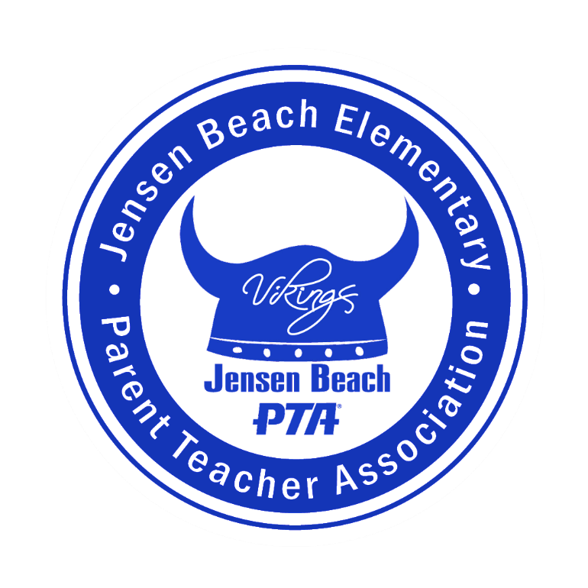
24th Fall Catalog Kickoff

September
6th PTA Board Meeting 6pm
15th Spirit Night – Hurricane Grill & Wings (Jensen)
22nd PTA General Meeting 6pm

October
4th PTA Board Meeting 6pm
15th Fall Festival
20th Spirit Night – TBD

November
1st PTA Board Meeting
17th Spirit Night – TBD

December
6th PTA Board Meeting 6pm
12th-16th Holiday Shop
14th PTA General Meeting 6pm
14th Evening Holiday Shop open 4-6

January
5th PTA Board Meeting* (Thursday)
19th Spirit Night – TBD
26th Movie Night 5:30pm

February
7th PTA Board Meeting 6pm
10th Father/Daughter Dance 6pm
16th Spirit Night – TBD

March
7th PTA Board Meeting 6pm
21st PTA Round UP 6pm-7pm
24th Mother/Son Bowling 6pm

April
4th PTA Board Meeting 6pm
21st Family Food Truck Night/PTA General
Meeting

May
2nd PTA Board Meeting 6pm
18th Spirit Night – TBD
26th Last day School

