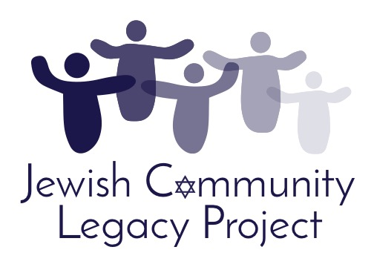
Program Overview
&
FAQs

in partnership with:
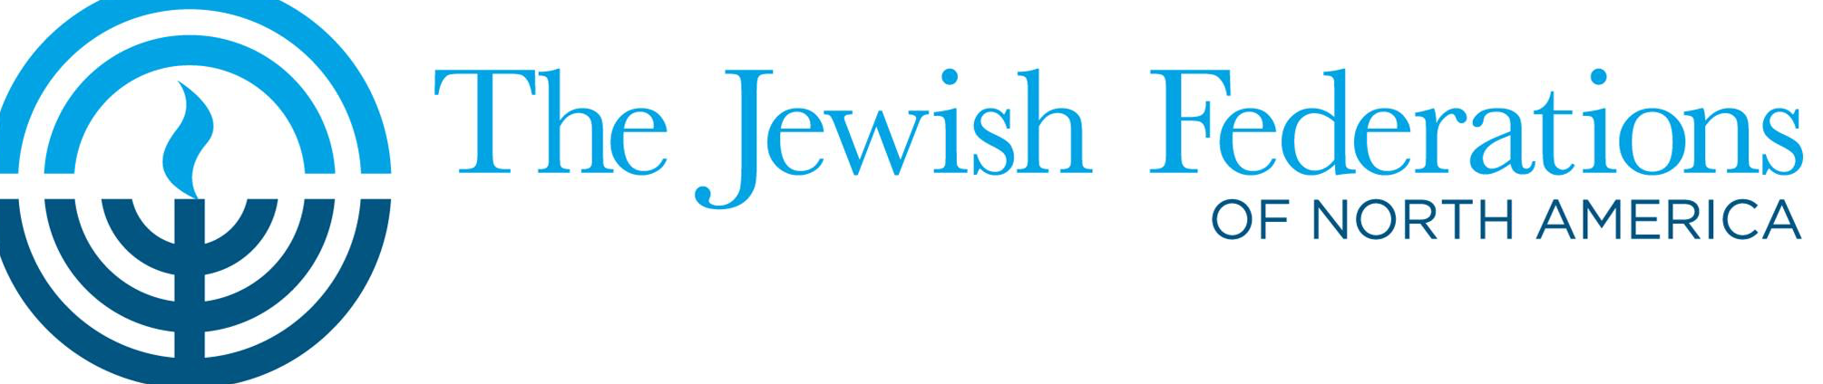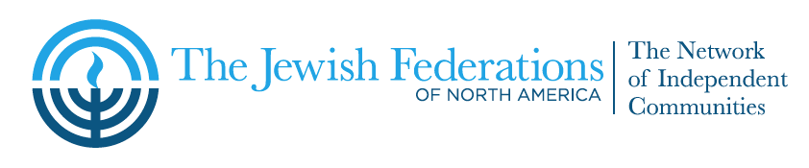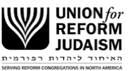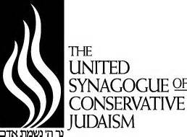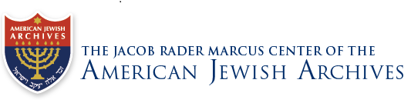
What is the mission of the Jewish Community Legacy Project?
The Jewish Community Legacy Project (JCLP) addresses the need for small Jewish communities to plan for a time when faced with aging and changing demographics such that they no longer can sustain themselves. JCLP engages local leadership in the creation of a “Communal Legacy” that honors the past and perpetuates the congregations’ legacies long after they cease to exist.

What does JCLP do?
JCLP works with congregational community leaders to sustain active Jewish life as long as possible while also helping them to shape forward-thinking plans that will address their building and other assets, their religious and historic artifacts and, if applicable, the maintenance of their cemeteries and monuments. Great care is also given to archive individual and congregational histories so that these stories live on in perpetuity.

When should JCLP be called?
There are four indicators of a diminishing Jewish community:

- Declining congregational membership and few, if any, new members
- Increased average age of members
- Few or no children in the religious school
- Leadership responsibilities falling on fewer and fewer people

How does a congregation begin work with JCLP?
JCLP is introduced to the congregation. Congregational leadership invites a representative from JCLP to explain how JCLP can be of help to the congregation. Once leadership decides to engage in the JCLP planning process, a working committee is identified and the JCLP/congregation partnership is soon underway. Congregations are asked to enter into an agreement with JCLP once they have committed to developing the plan.

What is in the JCLP agreement?
JCLP agrees to facilitate the planning process and introduce the congregation to other congregations, organizations and individuals well suited to assist with ongoing cemetery maintenance, placement of religious and historic artifacts, and continuation of philanthropy. The congregation agrees to work in a timely manner to develop a plan and to identify at least one way to leave a Jewish imprint after the congregation closes its doors.

How long does it take to create a Legacy Plan?
The congregation drives the timeline for plan development and completion. While a dedicated and focused committee is able to complete a Legacy Plan in 12-16 months, congregational leadership often chooses to spread the work across a longer time frame.

What are some examples of how Legacy congregations have chosen to leave their legacies?
Legacy Plans establish endowments that indicate how the congregation’s assets can be distributed to support a variety of Jewish causes that reflect the interests and values of the congregation. These may include: youth camping and Israel travel scholarships, social welfare projects, Holocaust education, the donation of Torah scrolls and other ritual objects to new and growing congregations and other Jewish institutions. Endowments have also been established for Legacy programs in the general community in which the congregation is located. Historical documents are donated to national and/or local Jewish museums and archives.

How much do congregations pay to participate in JCLP?
There is no charge to work with JCLP. Funding is provided via individual gifts, grants, Federations, and Legacy congregations. We do suggest that congregations consider including in their Legacy plans an allocation to JCLP to fund outreach to other congregations in need of similar Legacy planning.

How is JCLP managed?
JCLP has two lay advisory committees: one consisting of representatives from JCLP’s national partners: the Union for Reform Judaism (URJ), United Synagogue of Conservative Judaism (USCJ), and the Jewish Federations of North American (JFNA); the other consisting of representatives from JCLP congregations. JCLP also partners with local federations, Jewish foundations, museums and other institutions to help meet the needs of JCLP congregations. JCLP partners with an approved Jewish non-profit organization that serves as its fiscal agent.

Does a congregation have to be affiliated to participate?
No. JCLP works with congregations of all Jewish denominations regardless of affiliation. JCLP also works with unaffiliated congregations. Congregations affiliated with URJ and USCJ may be eligible for Legacy dues and member status from their respective denominations.

To learn more about the Jewish Community Legacy Project, please contact:

www.jclproject.org

Noah Levine
l_noah@bellsouth.net
678.429.8895

David Sarnat
dsarnat@gmail.com
770.690.8230

JCLP Communities:

Alton, IL Auburn, ME Auburn, NY
Bluefield, WV Butte, MT Danville, IL
Du Bois, PA Fitzgerald, GA Fort Smith, AR
Greensburg, PA Hazelton, PA Hot Springs, AR
Jefferson Hills, PA Jonesboro, AR Kokomo, IN
Lake Charles, LA Latrobe, PA Lima, OH
Manitowoc, WI Marion, IN Marion, OH
Martinsville, VA McGehee, AR Monessen, PA
New Castle, PA Niagara Falls, NY Oak Ridge, TN
Olean, NY Parkersburg, WV Petersburg, VA
Pine Bluff, AR Piqua, OH Portland, ME
Quincy, IL Steubenville, OH Sumter, SC
Trenton, MI Uniontown, PA Victoria, TX
Washington, PA Waycross, GA Whiteville, NC

Federations:

Austin, TX Buffalo, NY
Charleston, SC Charlotte, NC
Dallas, TX Detroit, MI
Greensboro, NC Houston, TX
Northeastern NY Indianapolis, IN
Little Rock, AK Pittsburgh, PA
Richmond, VA St. Louis, MO
Southern Illinois Syracuse, NY

Community Foundations:

Coastal Community Foundation, SC
Columbus Jewish Foundation, OH
Houston Jewish Community Foundation, TX
Jewish Foundation of Charlotte, NC
Richmond Jewish Foundation, VA
Foundation of Jewish Philanthropies, NY

