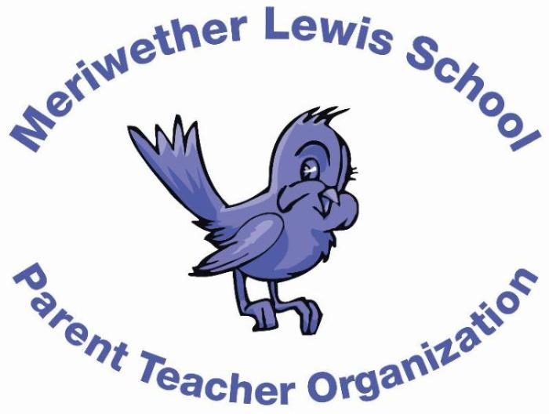
VOLUNTEER OF THE MONTH
January 2015

Samantha
Hartog
Annual Fund Co-Chair

Years as MLS Parent: 1 year
Children: Mackey (6), Virginia (4), and Hank (1)
First Volunteer Job at MLS: This one! Annual Fund Co-Chair.
Advice to someone who would like to volunteer at MLS: It will be more rewarding and fulfilling than you expect and you will meet many amazing people along the way.
Favorite Charlottesville area restaurant: Gotta go with Duner’s
Favorite Charlottesville family activity: Fall Foxfield
Favorite MLS event: Kindergarten Halloween program and pumpkin carving
Always wanted to learn how to: sew

