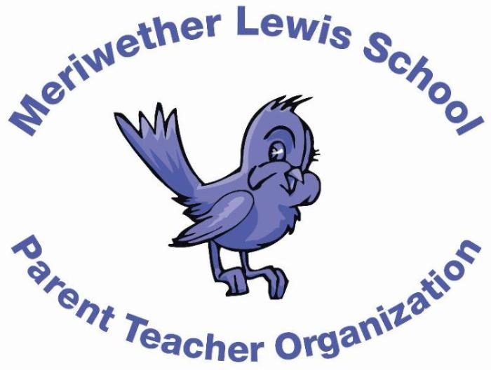
VOLUNTEER OF THE MONTH
September 2014

Laura Steenburgh
Parent Council representative; former Co-President; all around dedicated volunteer
Years as MLS Parent: A little over two years.
Children: Jack, 3rd grade, and Kathryn, 6th grade at Henley.
First Volunteer Job at MLS: PTO Co-Vice President.
Advice to someone who would like to volunteer at MLS: Sign up for whatever you can do! Even if you only have the ability to help out on one day, for one event, your help is so appreciated! Just fill out the volunteer form and list your time restrictions and what you’d most enjoy doing. Volunteering is great for the school and it’s also a great way to get to know other parents.
Favorite Charlottesville area restaurant: Tavola
Favorite Charlottesville family activity: Hiking in the Blue Ridge Mountains.
Favorite MLS event: Silent Auction – it’s a fun social event and I’m always excited about my winnings!
Always wanted to learn how to: take really great photos and speak a second language fluently.

