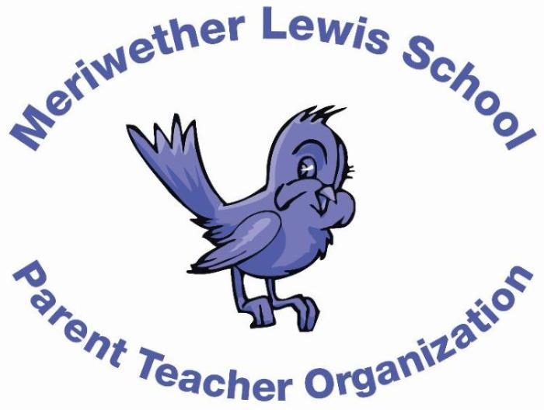
VOLUNTEER OF THE MONTH
February 2015
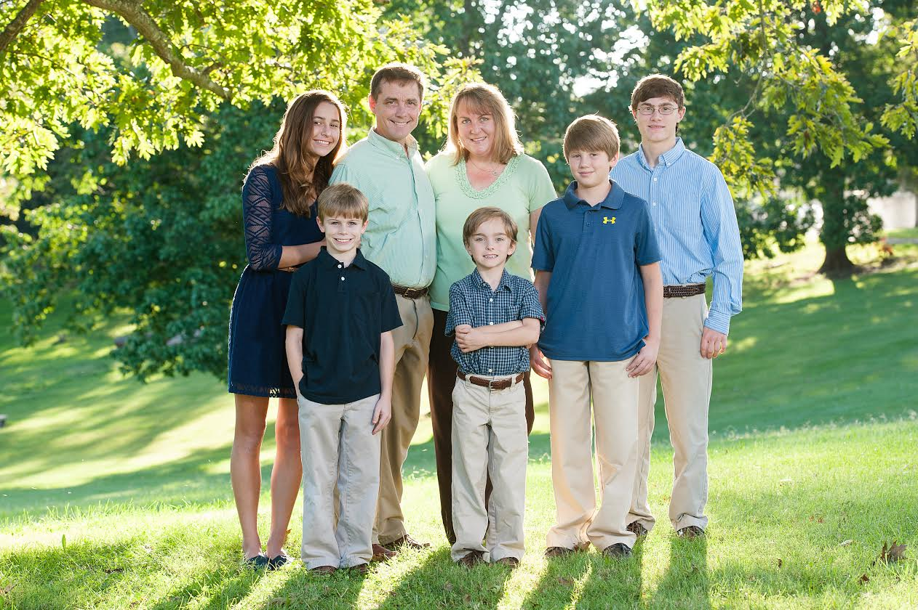
Years as MLS Parent: This is my 4th year as an MLS parent.
Brooke Reid
Box Tops Chair

Children: Canon (7), Nate (10), Micah (13), Faith (15), and Josh (18)
First Volunteer Job at MLS: Box Tops. We moved to Charlottesville in 2011 and I helped out in classrooms the first year, then volunteered for Box Tops in 2012.
Advice to someone who would like to volunteer at MLS: Of course volunteering is an important way to support the school. Being new to the community, volunteering is also a great way to get to know the teachers, students, and fellow parents.
Favorite Charlottesville area restaurant: Duner’s for a special date night with my husband
Favorite Charlottesville family activity: Going to a UVa basketball game. Sugar Hollow.
Favorite MLS event: Our family enjoys the Fun Fair.
Always wanted to learn how to: Play the piano!

