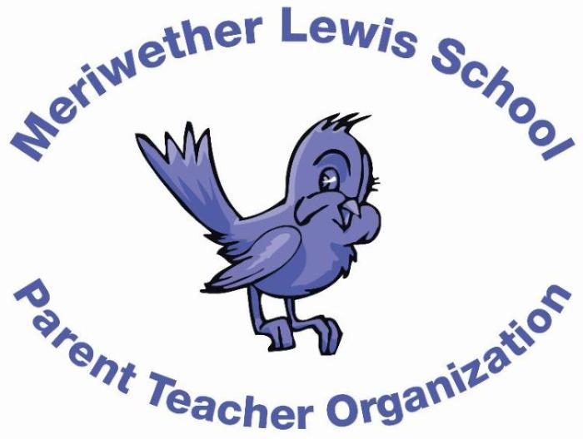
VOLUNTEER OF THE MONTH
October 2014

Rebecca Martin
Fun Fair Co-Chair
Years as MLS Parent: 2 years
Children: Anna (6) in Mrs. Jackson’s class and Emma (2)
First Volunteer Job at MLS: Kindergarten room parent
Advice to someone who would like to volunteer at MLS: Go for it! The school staff and parent volunteers are so much fun to work with. I’ve made some great friends by volunteering in the school.
Favorite Charlottesville area restaurant: Continental Divide
Favorite Charlottesville family activity: Chiles Orchard (picking strawberries, peaches, apples, pumpkins, etc.)
Favorite MLS event: Fall Fun Fair
Always wanted to learn how to: Make curtains, clothes, etc. or just how to sew a button!

