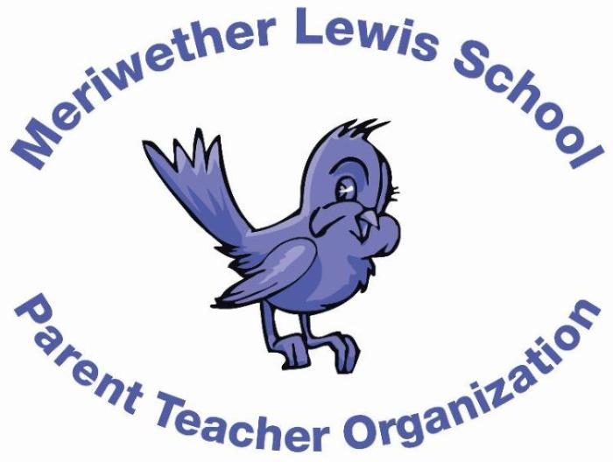
VOLUNTEER OF THE MONTH
October 2014
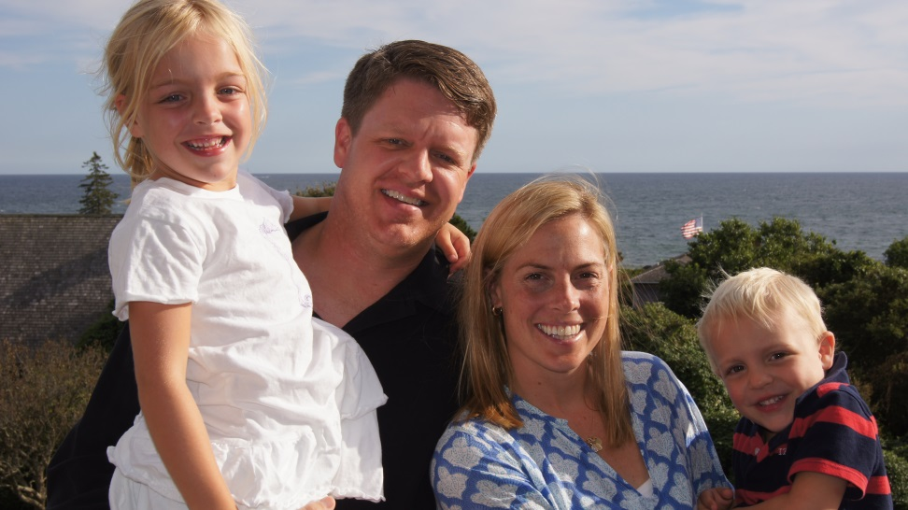
Years as MLS Parent: 2 years
Kristen Jamison
Fun Fair Co-Chair

Children: Lily (6), 1st grade; Bodie (4), pre-K
First Volunteer Job at MLS: Hospitality Committee
Advice to someone who would like to volunteer at MLS: I would say, “Jump in!” and don’t feel like you have to make beautiful fondant cupcakes from scratch or sew homemade decorations. Cupcakes and streamers from the store and your time make a huge impact!
Favorite Charlottesville area restaurant: Doctor Ho’s pizza!
Favorite Charlottesville family activity: Hiking/ splashing in the river at Sugar Hollow
Favorite MLS event: The Fun Fair!
Always wanted to learn how to: Get organized…

