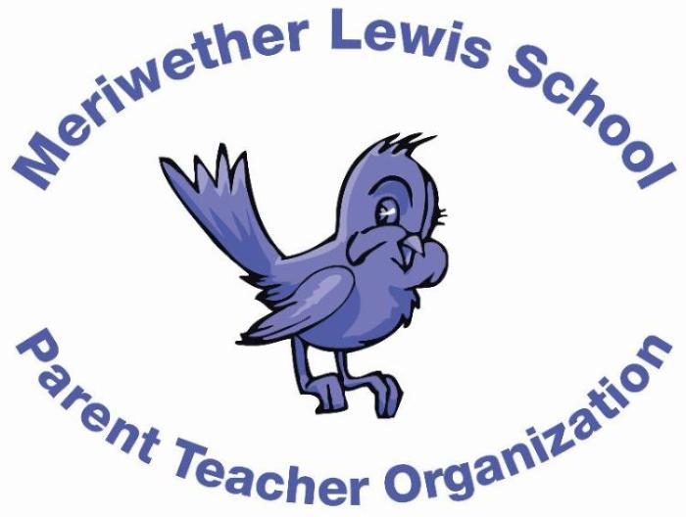
VOLUNTEER OF THE MONTH
January 2015

Bryce Harris
Annual Fund Co-Chair
Years as MLS Parent: 5 years

Children: Bode (11), Kaki (9), Leila (5), and Steele (2)
First Volunteer Job at MLS: Reading in the classroom.
Advice to someone who would like to volunteer at MLS: Jump in and contribute wherever you can. It’s such an amazing group of parents and kids.
Favorite Charlottesville area restaurant: Three Notched Grill
Favorite Charlottesville family activity: Any UVa sporting event!
Favorite MLS event: Talent Show
Always wanted to learn how to: Speak French

