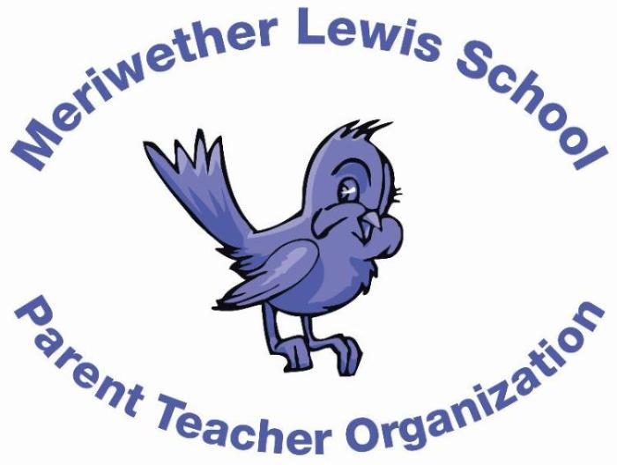
VOLUNTEER OF THE MONTH
December 2014

Years as MLS Parent: 4 years (My kids were previously at Stoney Point Elementary.)
Lisa Goldstein
Kids Market Charity Donation Coordinator; various volunteer activities

Children: Kase, 1st grade with Mrs. Oehler; Reeve, 3rd grade with Ms. Straume; Nate, 6th grade; Gigi, 9th grade
First Volunteer Job at MLS: Volunteered in Ms. Wetmore-Simpson’s class making apple pies, then the Silent Auction
Advice to someone who would like to volunteer at MLS: Do it! Any amount of time that you can help counts! It’s a great way to get to know the parents as well as the kids! Really, the volunteers are doing such great work (along with the teachers).
Favorite Charlottesville area restaurant: Who goes out to dinner with four kids? ;) OK, I love Mas.
Favorite Charlottesville family activity: So many … any UVa sporting event, hiking at Sugar Hollow or Humpback Rock (with Huck the dog too).
Favorite MLS event: Any event that includes the kids doing a Mr. Williams dance. He is the best at getting them moving, energized, and happy. It’s contagious!
Always wanted to learn how to: Knit. I have some master knitters here after being in Ms. Wetmore-Simpson’s class, but the talent seems to have skipped me!

