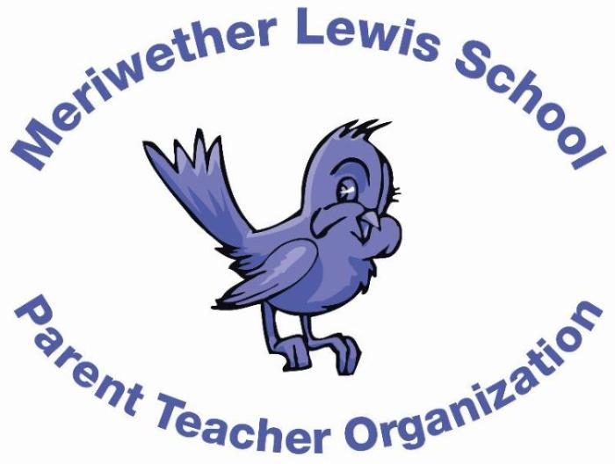
VOLUNTEER OF THE MONTH
October 2014

Years as MLS Parent: 4 years
Julie Chung
Fun Fair Co-Chair

Children: Sophia Park (10), Audrey Park (8), Beatrice Park (6)
First Volunteer Job at MLS: Room parent for Mrs. Sadler
Advice to someone who would like to volunteer at MLS: So many of the wonderful programs and activities that our children enjoy at MLS are only possible with the help of volunteers. Share your talents. For example, the signage, fliers, and decorations looked amazing at the Fun Fair this year due to the creative and graphic talents of several moms.
Favorite Charlottesville area restaurant: Himalayan Fusion, Downtown Mall
Favorite Charlottesville family activity: RV’ing
Favorite MLS event: Fun Fair!!!
Always wanted to learn how to: sail and fly fish

