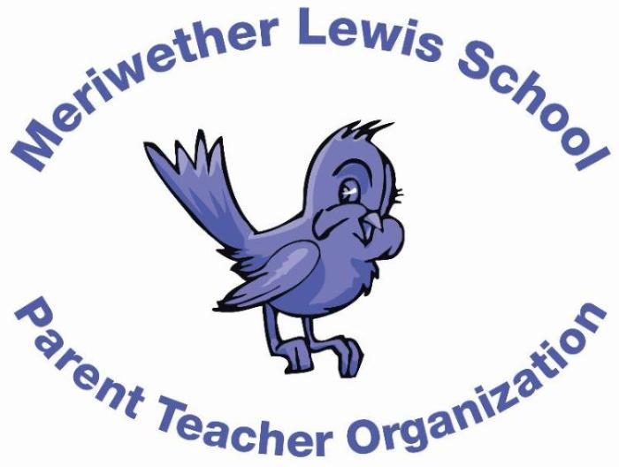
VOLUNTEER OF THE MONTH
November 2014

Years as MLS Parent: 11 years
Jennifer Bryerton
Family Game Night Chair
Children: Abby is 15 and in 10th grade at WAHS, Beth is 12 and in 7th grade at Henley. Nate is in 3rd grade and Nicky, our youngest, is a kindergartner.
First Volunteer Job at MLS: Reading to the children in Ms. Gibson’s (Warren’s) kindergarten classroom 11 years ago!
Advice to someone who would like to volunteer at MLS: Jump in with both feet! It is a great way to get to know other families and the amazing MLS staff. There are always lots of people eager to lend a hand so it is easy too.
Favorite Charlottesville area restaurant: Duner’s for dates but you’ll more often catch us at Bodo’s grabbing a to-go bag to take on a hike.
Favorite Charlottesville family activity: Virginia Discovery Museum and ice cream on the Mall, but if we’re up for a drive, we love the Safari Park. And, yes, it also includes ice cream at the Pink Cadillac Diner across the street!
Favorite MLS event: Gosh, it’s hard to choose – we never miss any! Book Fair is a favorite as is Kids Market. I also love the holiday parties – especially Halloween.
Always wanted to learn how to: Be a farmer. I always loved The Little House on the Prairie books. However, since I grew up in a farming community, I also know the realities of the hard work involved so I nurture it as a pleasant daydream while I take care of our pet goats and chickens and putter around the veggie garden.

