


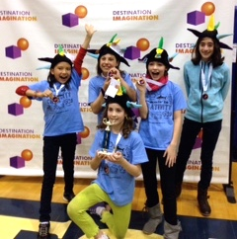
Sunday, May 17th
Noon – 10:00pm
Barracks Road Shopping Center

When you Treat yourselves, you Treat us too!
Friday, May 15th
5:30 – 9:30pm
Barracks Road Shopping Center
Tuesday, May 19th
8:00am – 8:00pm
2206 Ivy Road
Dine at the following establishments on the selected days and we receive a percentage of proceeds!

Introducing the DI Dragons Fundraising Restaurant Week
Hi Meriwether and Murray Families!

We’re the DI Dragons and as you might have heard, we are going to the Destination Imagination Global Competition next week to compete with 8,000 other students from 15+ countries! And as you also might have heard, we could use any and all help with some fundraising.

So…if you need a reason not to cook or want to take the family out for a sweet treat, NOW is the time to do it!
(xxx)yyy-yyyy
Organization

