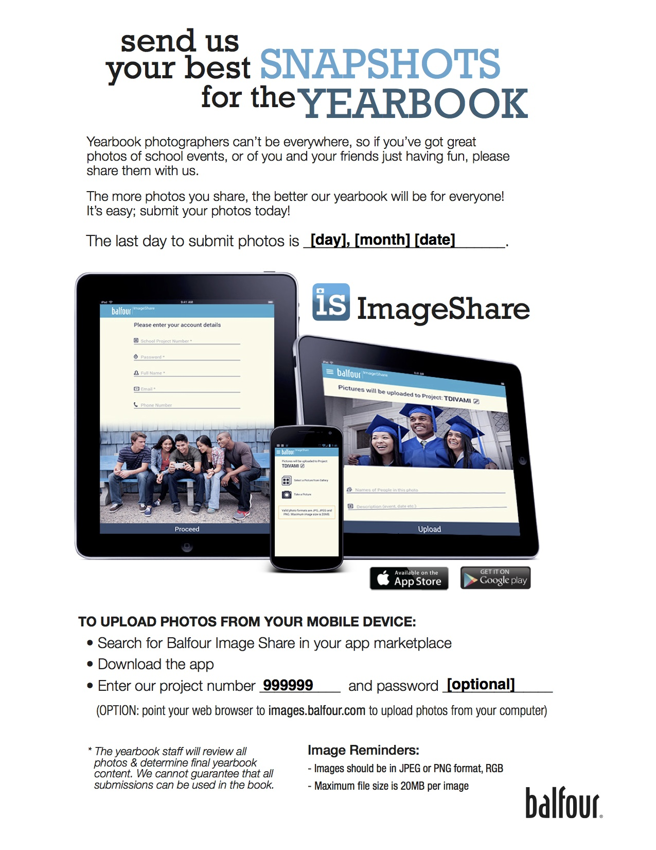
*Cell phone equivalent of iPhone 5 or higher only, please.
**Please contact Laura at ldruhl@mindspring.com with questions.
March 19, 2015
528147

MLSYB2015

