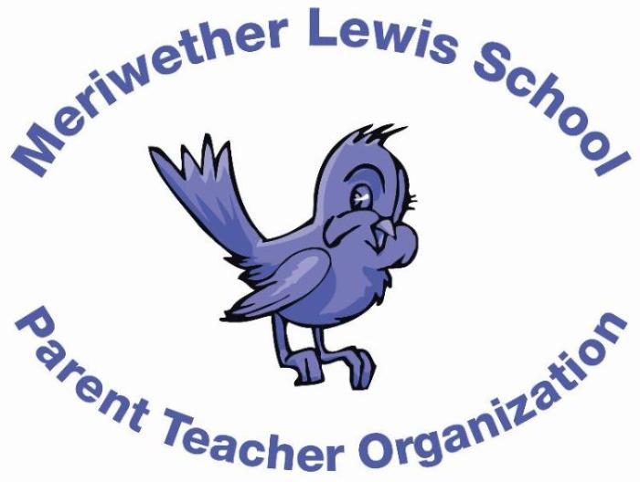
VOLUNTEER OF THE MONTH
September 2014

Kristina Parker
Landscaping & Gardening Chair; former Co-President; all around dedicated volunteer
Years as MLS Parent: This is my 4th year!
Children: Justin, 3rd grade, and Amber, 6th grade at Henley.
First Volunteer Job at MLS: Fun Fair Committee back in 2011.
Advice to someone who would like to volunteer at MLS: Volunteering at MLS is a great way to meet other parents, your children’s classmates, and to help make your child’s experience at school even better. When you volunteer, you really feel connected to the school and that makes it so much more enjoyable as a parent!
Favorite Charlottesville area restaurant: Bodo’s never disappoints!
Favorite Charlottesville family activity: It’s a tie between going to the Downtown Mall and hiking at Sugar Hollow.
Favorite MLS event: Family Field Day and Kid’s Field Day. I love helping at both!
Always wanted to learn how to: speak Spanish better. I learned in high school but haven’t practiced much since.

