**THE WORD FROM RICK – “Following Up, Part 1”**

Since the February 6 presbytery meeting, I have had a number of people comment about some of the information that I shared as part of my report, and others wondered if I could share some of the highlights in writing, fearing that they missed some things as they were trying feverishly to take notes.

In this week’s “Follow Up,” I want to again share some of what Rodger Nishioka, a professor at Columbia Theological Seminary in Decatur, Georgia, shared with us at the Association of Presbyterian Church Educators (APCE) event in Chicago.

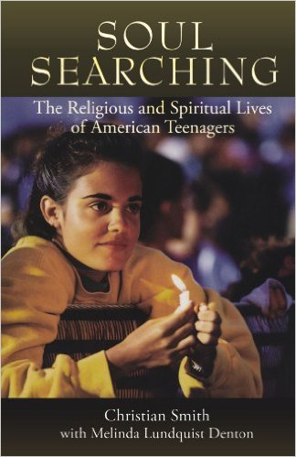Rodger’s presentation was entitled “Giving New Attention to Our Educational Ministry with the Family”, and some of the information that he shared with us . . . and that I passed on to you . . . was the following, regarding “emerging adults” (young adults) in America:

* 15% were considered to be Committed Traditionalists -- firmly engaged in the life of their faith community;
* 30% were considered to be Selected Adherents – those who continued to have a connection to their faith community;
* 15% were considered to be Spiritually Open -- most often they are “Spiritual, but not Religious” types who find their spiritually largely away from the faith community;
* 25% were considered to be Religiously Indifferent – these are the ones who said they could take it or leave it, and most chose to leave it;
* 5% were considered to be Religiously Disconnected – most likely as the result of a bad church experience;
* 10% were considered to be Irreligious.

Undergirding Rodger’s presentation, were the above statistics -- information that was gained from two studies that were published as two books – *Soul Searching: The Religious and Spiritual Lives of American Teenagers (2005)* and *Souls in Transition: The Religious and Spiritual Lives of Emerging Adults (2010).*

*Soul Searching* by Christian Smith, and others, set the stage. It reported the findings of The National Study of Youth and Religion, one of the largest and most detailed such study ever undertaken. The Study conducted a nationwide telephone survey of teens and significant caregivers, as well as nearly 300 in-depth face-to-face interviews with a sample of the population that was surveyed.

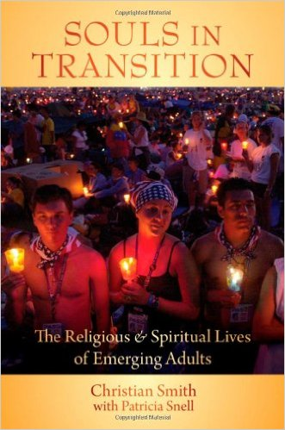Several years after *Soul Searching*, Smith followed up on those same youth and explored such questions as: How important is religion for young people in America today? What are the major influences on their developing spiritual lives? How do their religious beliefs and practices change as young people enter into adulthood? The result was Souls in Transition, which shared insights into the religious and spiritual lives of emerging adults, ages 18 to 24, in the U.S. today. The above the statistics emerged from this work and show how the religious practices of the teenagers portrayed in Soul Searching have been strengthened, challenged, and often changed as they have moved into adulthood. The book also describes the broader cultural world of today's emerging adults, how that culture shapes their religious outlooks, and what the consequences are for religious faith and practice in America more generally.

One of the most important discoveries of Smith’s work was that parents -- not the pastor, the peer group, the style of worship, or anything else – turned out to be the single most important influence on the religious outcomes in the lives of young adults. The way that their parents or caregivers demonstrated the important of the faith and investment in the faith community is the reason that young adults maintain an ongoing investment in the life and ministry of the church!

This is something which leads us, not only in this presbytery, but across the church to ask these questions:

* *What are the challenges we face in renewing our educational ministry with the family? How will we respond to these challenges?*
* *How will we encourage parents and caregivers to demonstrate and articulate the faith their children?*

Prayerfully ponder these questions, and please feel free to share your thoughts that we might learn from and encourage one another.

Grace and Peace to you all,

**Rick**