NAMI Maryland Partners with the
Mental Health Channel
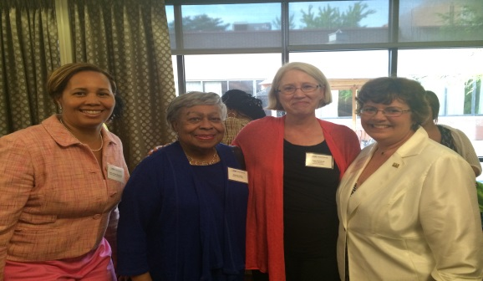
NAMI Maryland recently entered into a partnership with the newly created Mental Health Channel. The Mental Health Channel is an online network that's changing the conversation on mental health through inspiring true stories. The channel is creating engaging, enlightening and informative programming to help all viewers improve their mental health. With 12 series of original short documentaries already online, MHC provides insight on a wide array of mental health topics in often entertaining and unexpected ways. With help from NAMI Maryland, the channel will continue to create and upload more content. This is just the beginning!
From left to right: Dr. Gayle Jordan-Randolph,DHMH, Senator Dolores Kelley, Kate Farinholt, NAMI MD Executive Director, Daphne McClellan, Executive Director, National Association of Social Workers-Maryland
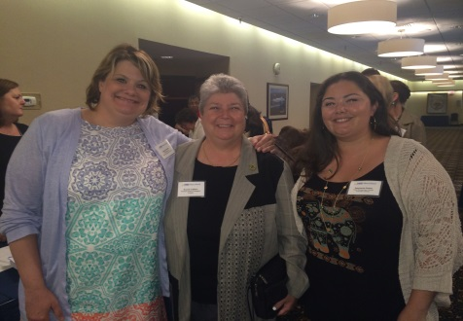
As part of our partnership, we hosted a launch
event on June 8 at the Conference Center at Maritime Institute in Linthicum Heights. Approximately 90 guests enjoyed a VIP reception with elected officials and government representatives. In attendance were Delegates Pat Young (D-44B) and Bonnie Cullison (D-19), and Senator Dolores Kelley (D-10) as well as Gayle Jordan-Randolph, Deputy Secretary, Behavioral Health at the Department of Health and Mental Hygiene.

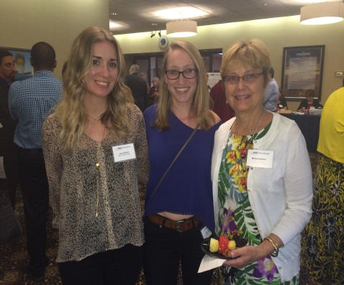
After the reception, guests
enjoyed a free program where individuals with mental illness and families shared their emotional and personal journeys with mental illness and recovery, interspersed with a sampling of the Mental Health Channel's short documentaries.
From left to right: Jess Honke, NAMI MD Policy and Advocacy Director, Delegate Bonnie Cullison, Stephanie Rosen, Executive Director of NAMI Montgomery County
From left to right: Mental Health Channel filmmakers Janice Woods and Rachel Ecklund, and NAMI member, Martha Dembeck
For more information about the Mental Health Channel, visit mentalhealthchannel.tv.

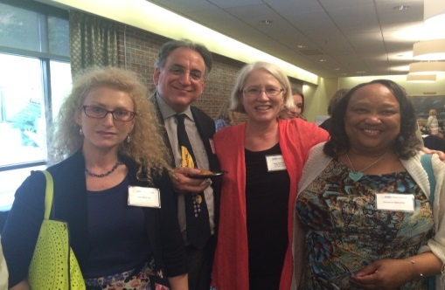
From left to right: Kim Komrad, Dr. Mark Komrad, Kate Farinholt, NAMI Maryland Executive Director and Deneice Valentine.

