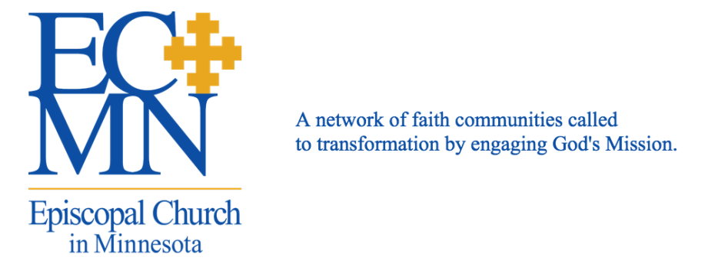
Response to Events in North Minneapolis
Dear People of God:
The Roman Empire turned its back upon tiny Bethlehem, and yet God showed up. Ignored by emperors and kings, Bethlehem was a speck on the map - if it even appeared at all. Yet Jesus entered the world in this place abandoned by empire and was Good News for those who lived there.
In the same vein, Minnesota turned its back upon North Minneapolis. White supremacy, economic disinvestment and government disinterest have been present in North Minneapolis for generations. We weep and mourn with the families of Jamar Clark and the five protesters who were shot - and we also acknowledge that this is not a new narrative. Still, as Christians we believe that Jesus is present: creating, transforming, and proclaiming Good News to a world that deeply needs it.
As you reflect upon the events of the past eight days since the shooting of Jamar Clark, we invite you to deeply consider engaging with the abandoned places of empire, at the margins of society. For some of us this might mean physically moving and buying one of the vacant properties in North Minneapolis. For others, this might mean finding ways to intentionally spend time, talent, and treasure in that neighborhood. Yet others might look in our own communities for neighbors and neighborhoods that have been abandoned, and add prayers for justice in North Minneapolis to our prayers.
As the church we can be complicit in supporting white supremacy or we can join with the Holy Spirit in actively interrupting the cycle of violence. We cannot choose the illusion of neutrality. To be "neutral" is to support a status quo that "corrupts and destroys the creatures of God" as we say in our Baptismal Covenant.
Below, there is a prayer that you can use. If your faith community plans to gather or participate in events responding to this situation, we invite you to let us know so that we can communicate your event. If you don’t know what to do, please contact Missioner for Community Engagement Rachel Babbitt, Rachel.B@episcopalmn.org.
Prayer in Response to Events in North Minneapolis
Gracious God, our times are in your hands.
You gave hope to our ancestors when they thought they were lost.
Your son Jesus taught us how to live with compassion and integrity in a time of great division and fear.
We pray for Jamar Clark, his family, and those protesters who were shot; for the police officers involved and their families; for those who incite violence; for the Minneapolis mayor and police unions; for the leaders of Black Lives Matter, Neighborhoods Organizing for Change, and all those affected by the events of recent days, especially residents of North Minneapolis and abandoned neighborhoods anywhere in our state.
Give us a holy intolerance for oppression - whether we are the oppressed or the oppressor.
Send your Holy Spirit into our hearts to replace our fear of each other with a longing for connection and trust.
Compel us to see your image in the Other, in our families, neighborhoods, houses of faith, workplaces, and civic conversations.
Give us the will to commit to reconciliation through relationship building and reinvestment in our neighborhoods.
Give us the guiding star of your Holy Spirit as we seek to heal our community.
In the name of Jesus, who broke bread with sinners and saints, friends and enemies, and spoke words of Good News into their hearts, and ours. Amen.
Blessings,
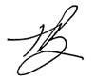
The Rt. Rev. Brian N. Prior
IX Bishop of the Episcopal Church in Minnesota

