All In Plan Implementation Update

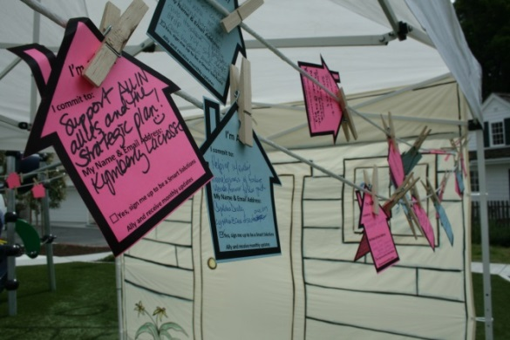

When All In- Toward a Home For Every County Resident: The Santa Cruz County Community Strategic Plan to Prevent, Reduce, and Eventually End Homelessness was launched in April this year, it outlined several areas essential to successful implementation, including increased coordination, staffing, and funding resources for housing. We would like to share just a couple of the implementation activities going on this summer.
Homeless Coordinator
In June, the County Board of Supervisors approved the creation of a new position to guide implementation of All In and support countywide homeless services provision and coordination. This is an extremely vital piece of implementation, because this additional designated person will be responsible for guiding, coordinating and assessing progress of this ambitious roadmap to end homelessness in our community. With this development, this position will join current staff in the Planning Department to harness the momentum built through the creation of the plan to ensure our individual efforts continue in coordinated strategies.
Ending Veterans Homelessness Working Group
The Veterans Housing Group has an ambitious goal: to reach “functional zero” for veterans experiencing homelessness in Santa Cruz County by the end of this year. This means the system in place houses more homeless veterans than become homeless. With the 2015 Point In Time Census identifying 155 homeless veterans, the group seeks to house 77 veterans a quarter to do this. They currently house approximately 30 a quarter.

The group, which consists of the Veterans Resource Center (VRC), HUD-VASH, Supportive Services for Veteran Families (SSVF) providers, Homeless Services Center, Pajaro Valley Shelter Services and others, will soon be meeting weekly (twice as often as they do now) to increase their coordination to work in concert, rather than separately. This level of coordination is precisely what All In calls for to effectively end veteran homelessness. They have already created a single master list of veterans in need of housing in the county and meet to coordinate who has been housed and those next in line should a unit become available. Which brings us to the principal barrier to ending veteran homelessness: there are not enough housing units that accept the HUD-VASH housing vouchers. The VRC recently received a substantial grant of $3.5 million to house veterans and with the work the Landlord Outreach Working Group (below) is poised to do, our community may soon be joining New Orleans and others in ending homelessness among those who have served in the military.

Landlord Outreach Working Group
As a result of the All In launch event in April, community members volunteered to help with various aspects of implementation. One idea whose time had come was the creation of a Landlord Outreach Working Group to increase the number of landlords that will accept HUD-VASH and Section 8 Housing Choice Vouchers. The County Planning Department and Housing Authority of Santa Cruz County have led the effort, convening several agencies and individuals who have independently been doing this work.

The group has broken into "task units" to address key areas including designing a landlord incentive program, coordinating a master affordable properties list, media publicity, and marketing and outreach to landlords. The primary working group will convene again in the fall to coordinate these efforts and launch a countywide campaign to increase our pool of landlords who accept and support Housing Vouchers. This is an absolutely critical piece of providing permanent supportive housing to hundreds of disabled, veteran, and chronically homeless individuals and families in our community. Stay tuned for how you can get involved later this year.

