Smart Solutions House Gatherings

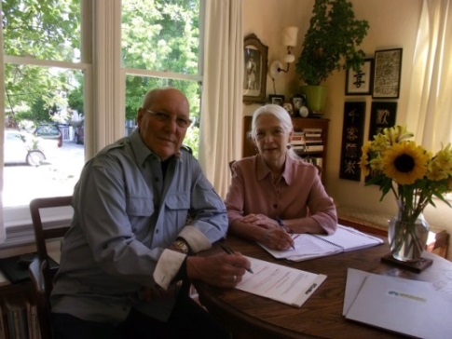

"I learned tonight that every homeless person has a story, and that there are some good ways to respect and approach homeless people in a friendly and open manner." "I will be able to be more thoughtful and questioning about issues of homelessness and especially about individual people who are homeless." These insights were gained by two House Gathering participants after one of the first evening conversations hosted by Smart Solutions.
House Gatherings are casual living room gatherings of the host’s friends, neighbors, co-workers, and acquaintances to socialize together with food and conversation, to participate in a one and a half hour dialogue and considerations about homelessness. Annette March and Robert Graham (pictured above) established these local events designed to shift our everyday culture and beliefs about homelessness through personal interaction.
The socializing aspect of the house gatherings is central to their success, designed to foster safe, exploratory dialogue among homeless people and housed people. Guests talk with their friends and new acquaintances, feeling comfortable and “at home” with the conversation and dialogue of the presentation.
The presentation is designed to inform participants about homelessness in Santa Cruz County and nationally, to acquaint guests with some of their homeless neighbors, and to offer opportunities to reflect more deeply about the issues. Guests will understand more about initiatives that are currently taking place locally to serve people experiencing homelessness, and about initiatives that are planned for the near future.

The house gathering is not a fund raiser, but an opportunity for guests to engage in practical solutions to homelessness in our county. Guests are invited to act in small or large ways on their new-found understandings about homelessness through the use of action “pledges”. Actions might be as small as making eye contact with a person on the street, or saying hello. For those who might wish to participate in one of the many local organizations that serve people who are homeless, information will be provided.

If you are interested in hosting a house gathering, please contact Robyn McKeen, Smart Solutions coordinator, at rmckeen@unitedwaysc.org.

One House Gathering participant summarized their take-away from the evening powerfully "I am hopeful. There is a chance for change.”

