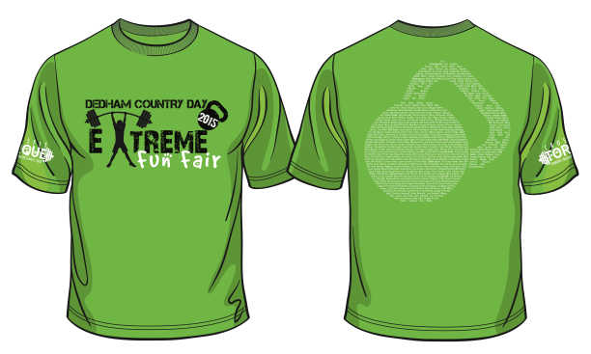

Heavy Duty 100% Cotton – Pre-Washed – Pre-Shrunk T-Shirts!!

Please use your youngest child’s first name and grade when ordering more than one shirt.

Last Name
First Name
Grade

Designate the quantity in the box below each size.

 | Youth Sizes $15.00 |  |  |  | Adult Sizes $15.00
 | YS  6–8 | YM  10–12 | YL  14–16 |  | S | M | L | XL | XXL
Lime Green with names on back
Black with names on back
Lime Green without names on back
Black without names on back

Total # of Shirts: | Amount Due:

Please return your order form and check to the Fair mailbox in Barbara Laneau’s office by
Wednesday, April 15.

Please make your check payable to Dedham Country Day School and write “T-shirts” on the
memo line of the check.

